**Course Name:** Laboratory Practice II(310258):Cloud Computing

**Assignment No:** 2

## Title of Assignment:

Installation and configure Google App Engine.

## Objective:

1. Install and Configure Google App Engine
2. Create a simple code in python on Github and execute on Google App Engine
3. **Outcome:** Use tools and techniques in the area of Cloud Computing

Steps □

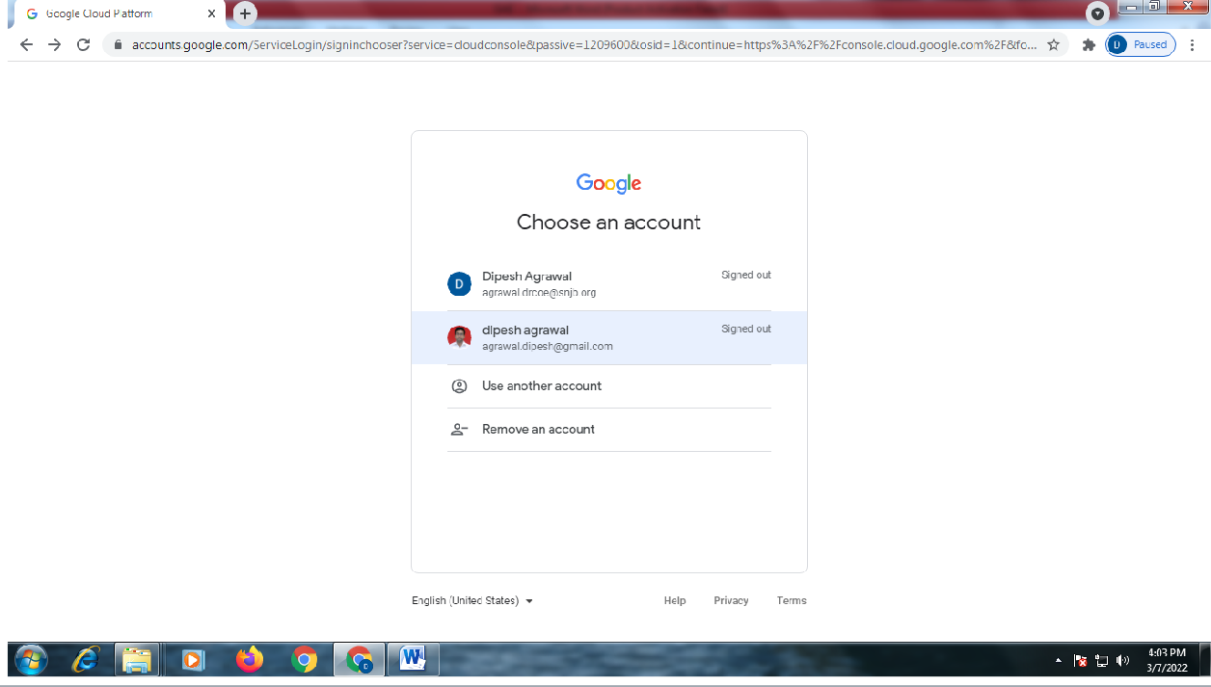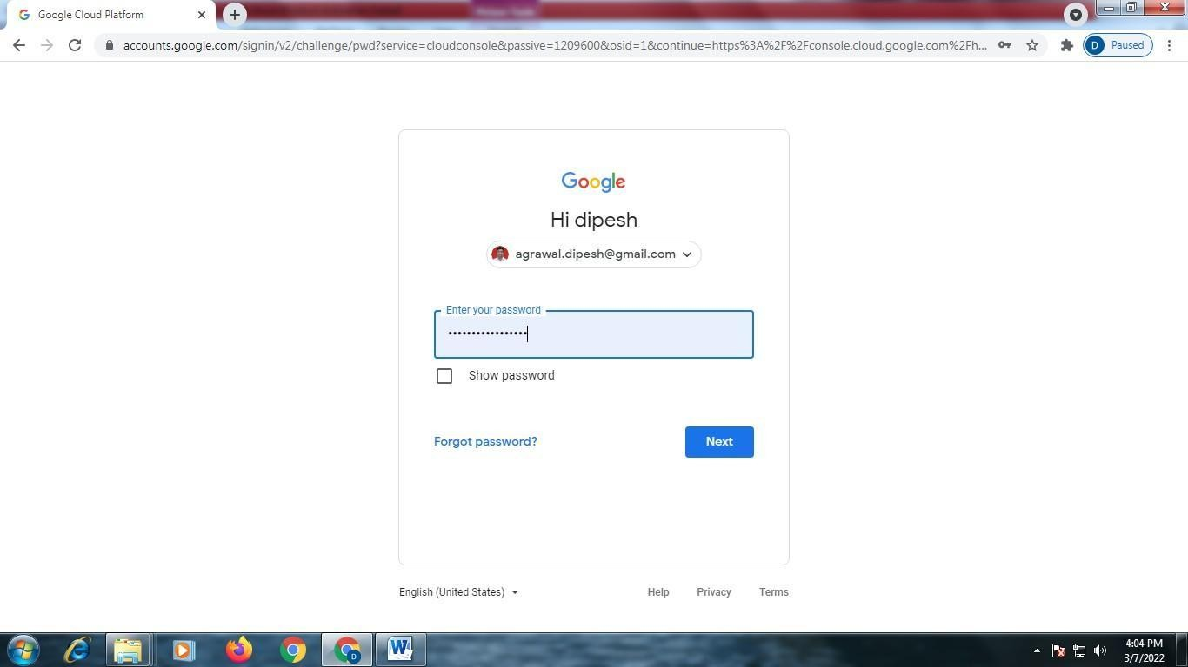

Following Screen Will Appear

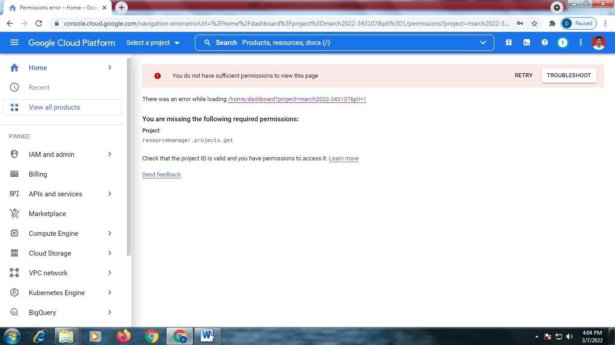

Click on □ Select new project

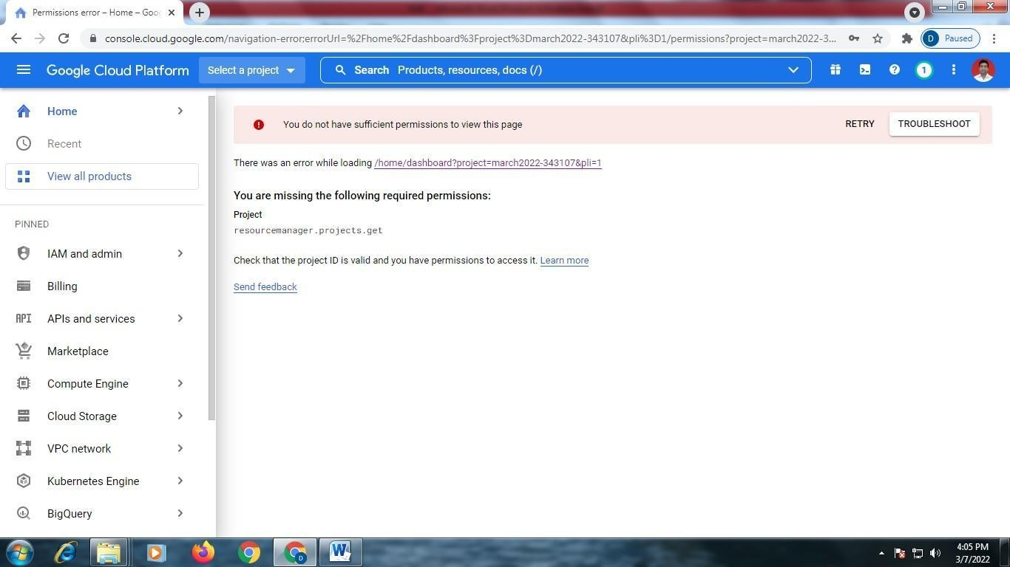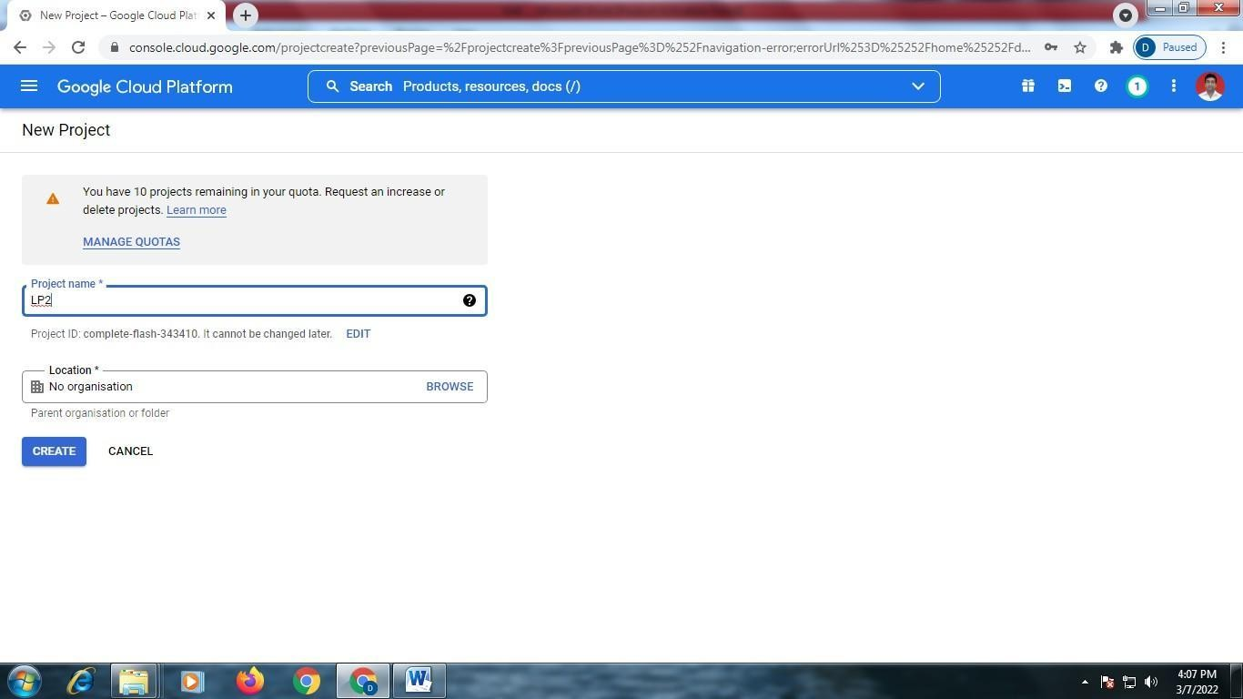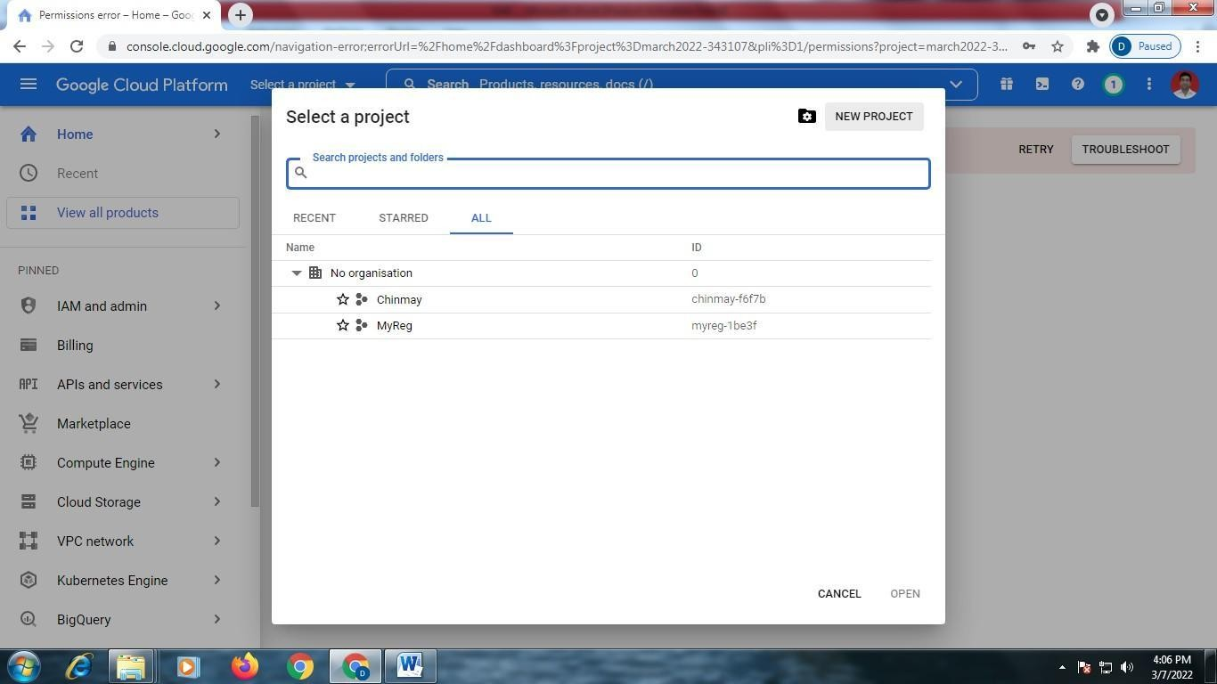

Click on □ New project –

Give project name



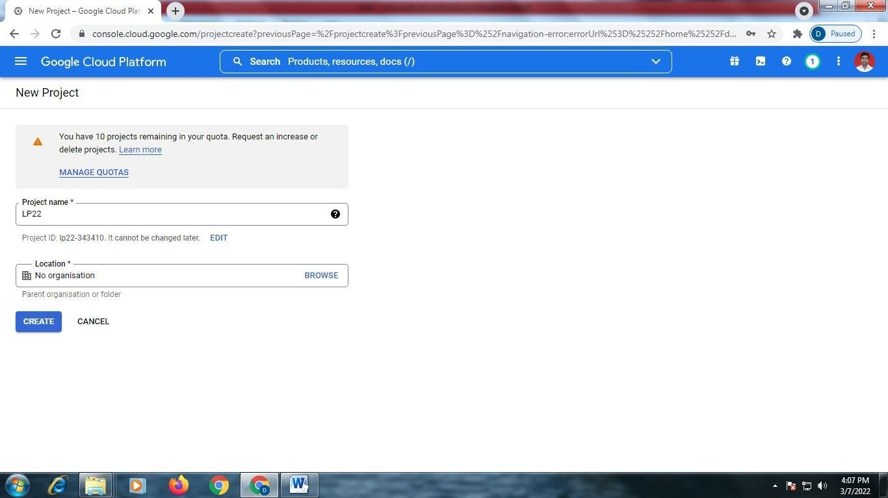

Click on □ create

Click on □ Select Project

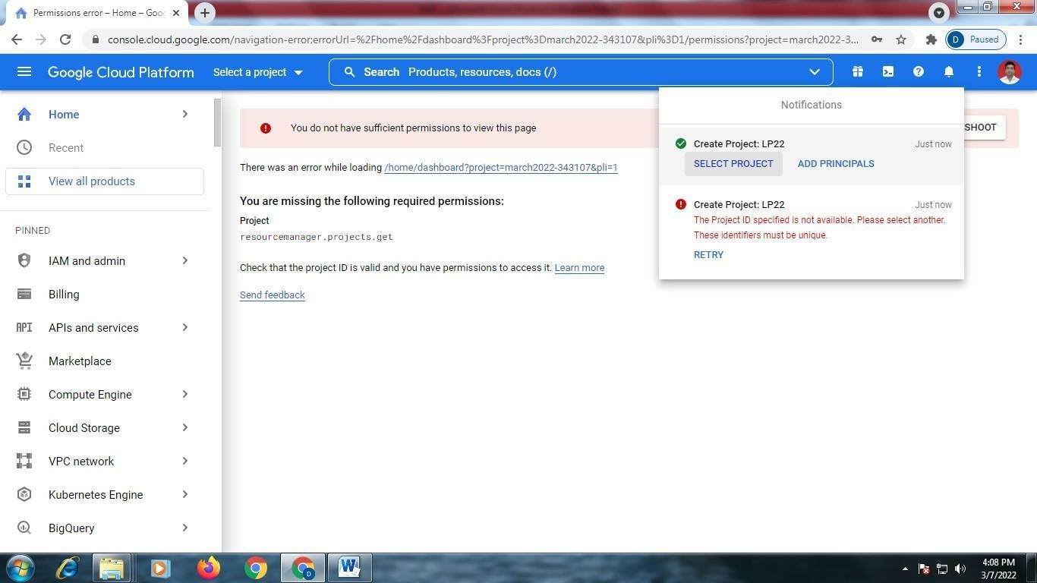

In search □ type ―App Engineǁ

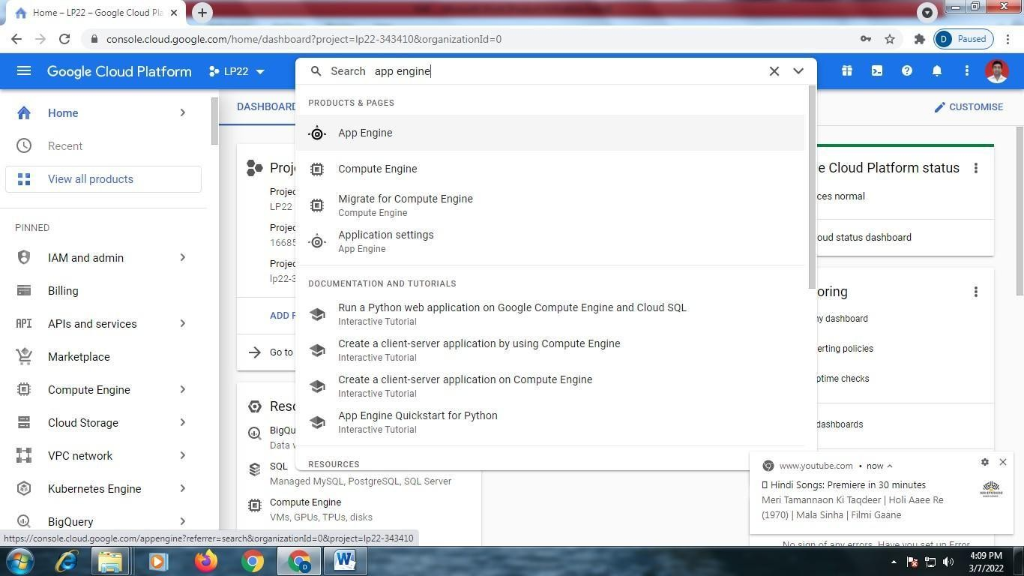

Click on – ―App Engineǁ Following screen will appear

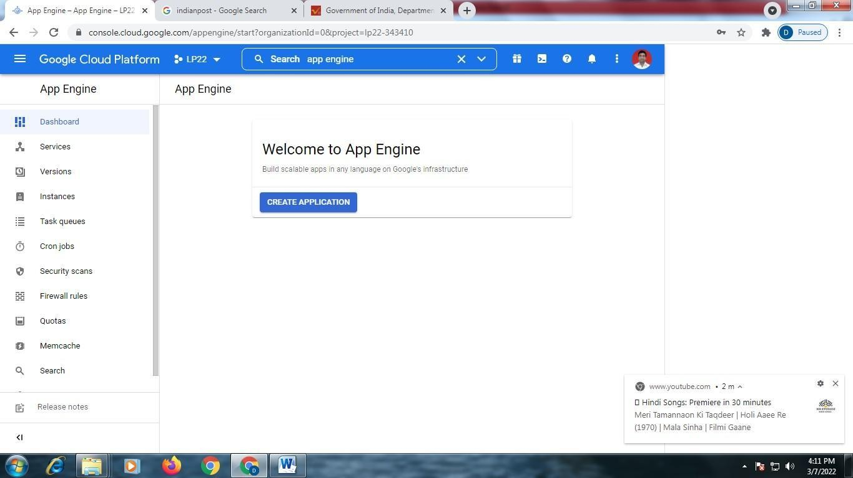

Click on □ ―create Applicationǁ Following screen will appear

Scroll Down

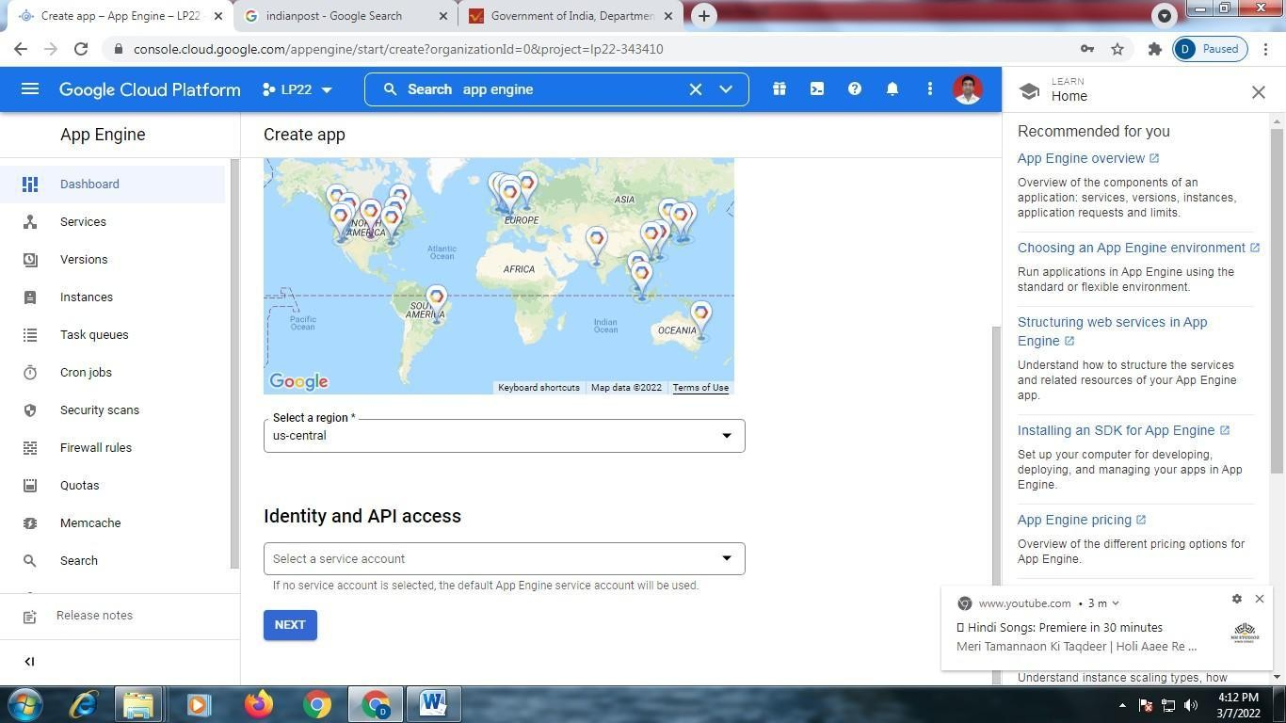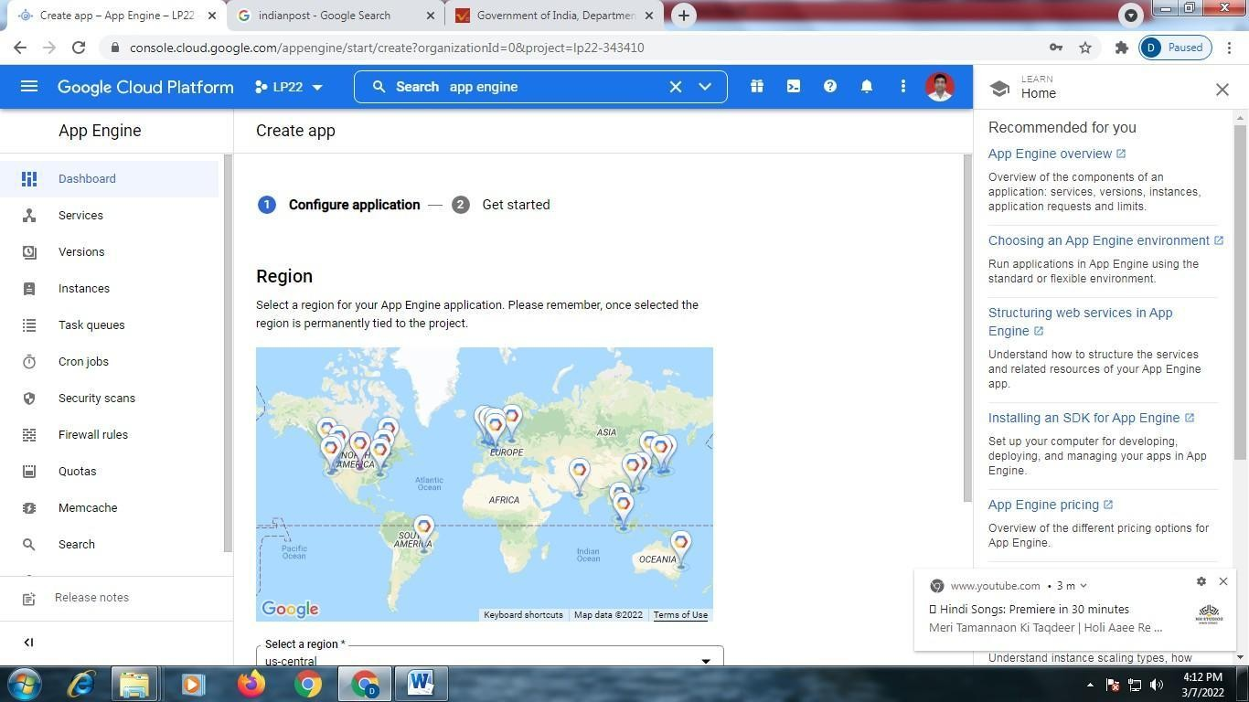

Click on □ ―Nextǁ

Following Screen Will Appear

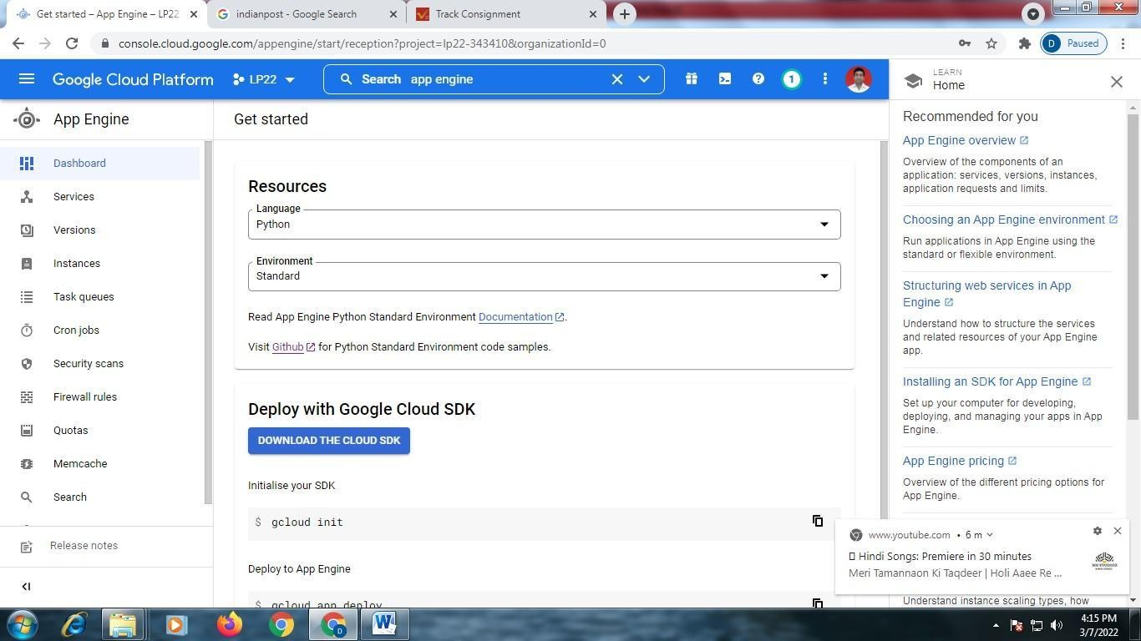

Scroll Down □Click on – ―I will do it Laterǁ

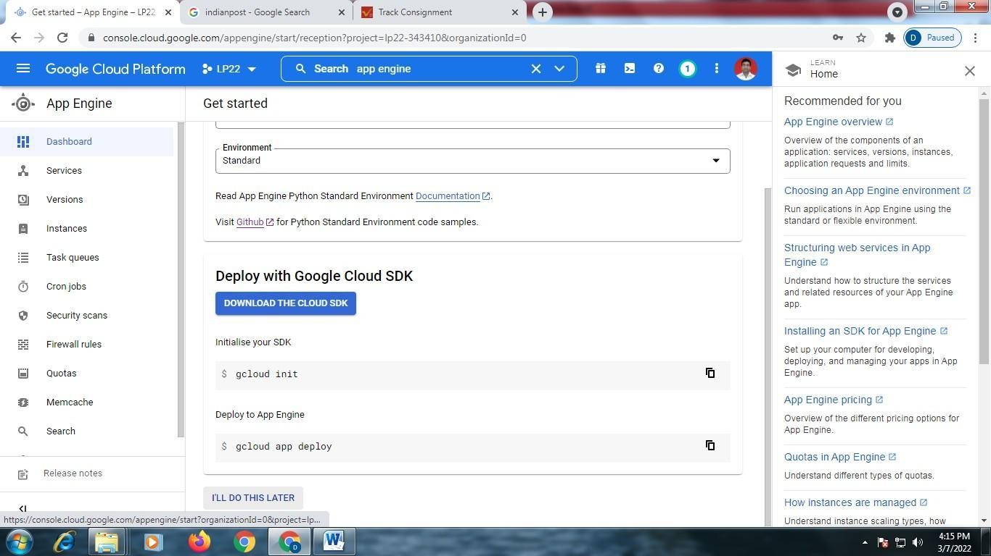

In search box, type □ ―App Engine Admin APIǁ

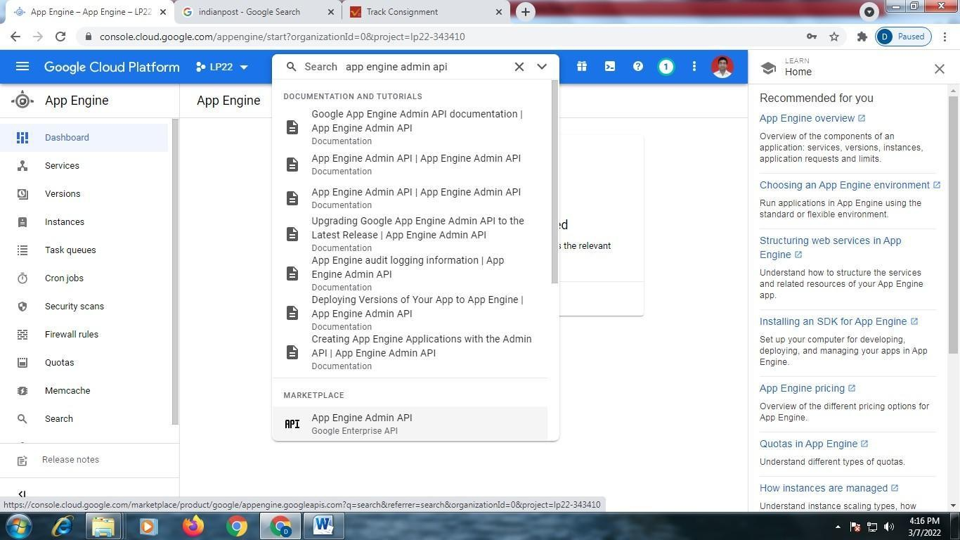

Click on □ǁApp Engine Admin APIǁ Click on ―Enableǁ □

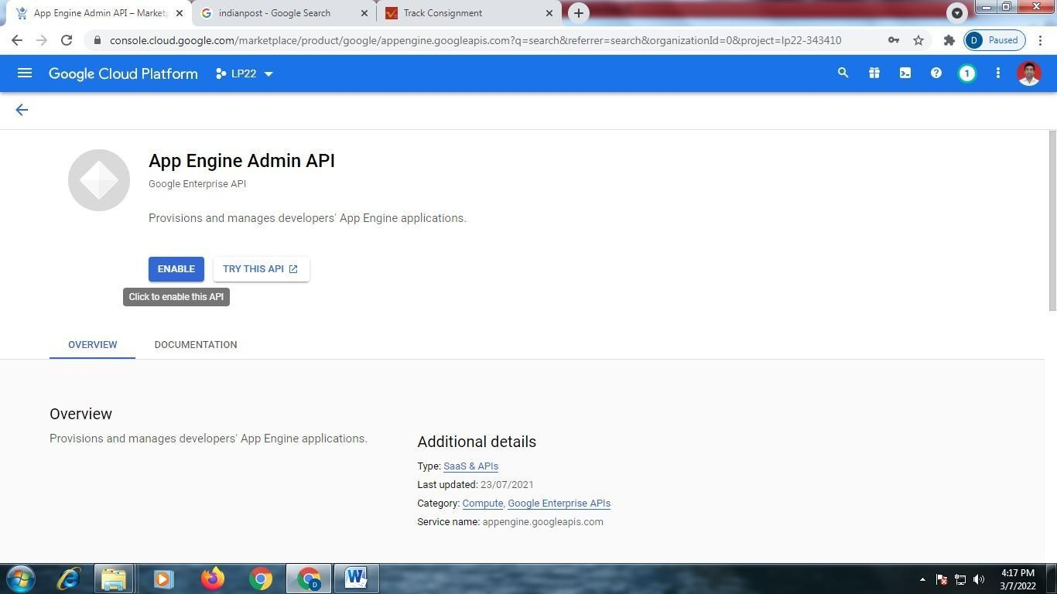

Click on □ ―Activate Cloud Shellǁ

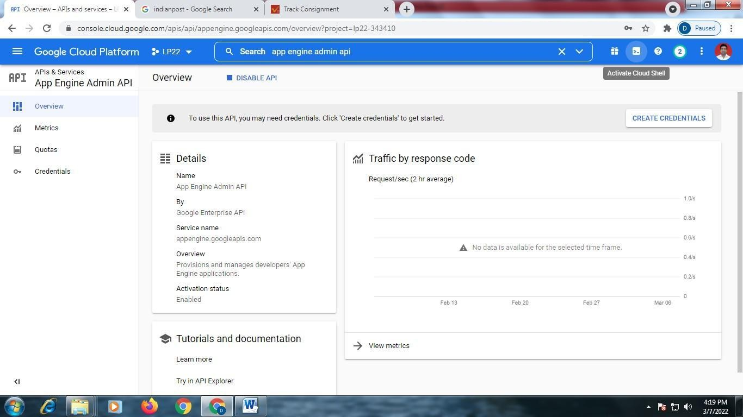

Click on □ ―Continueǁ

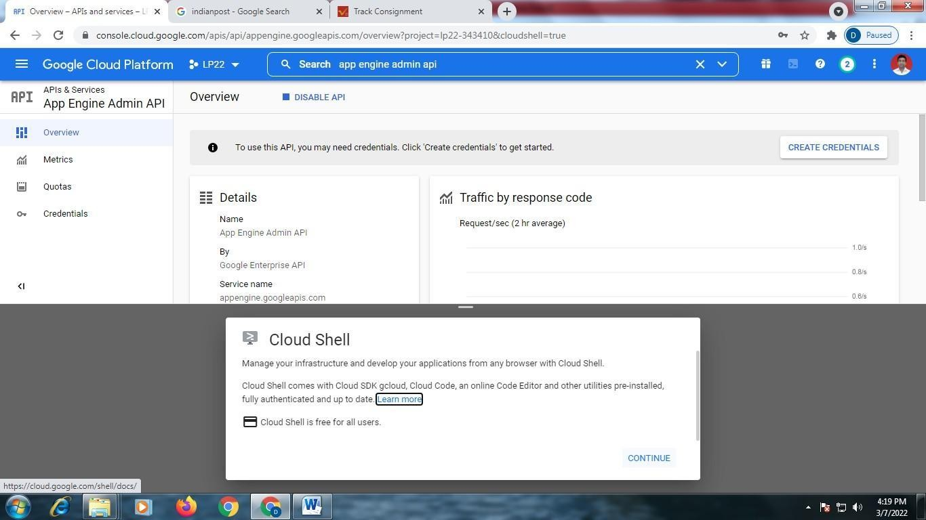

Following Screen will appear

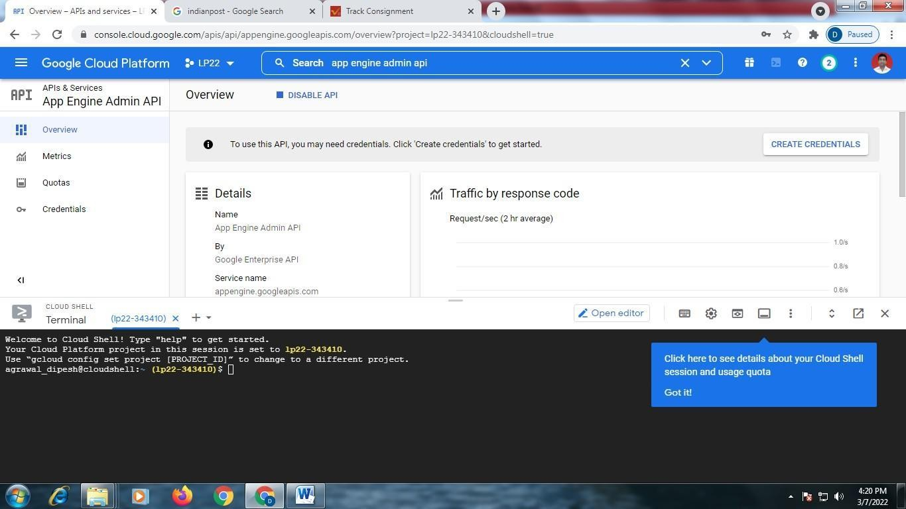

Login to your Github Account □ Click on ―New Repositoryǁ

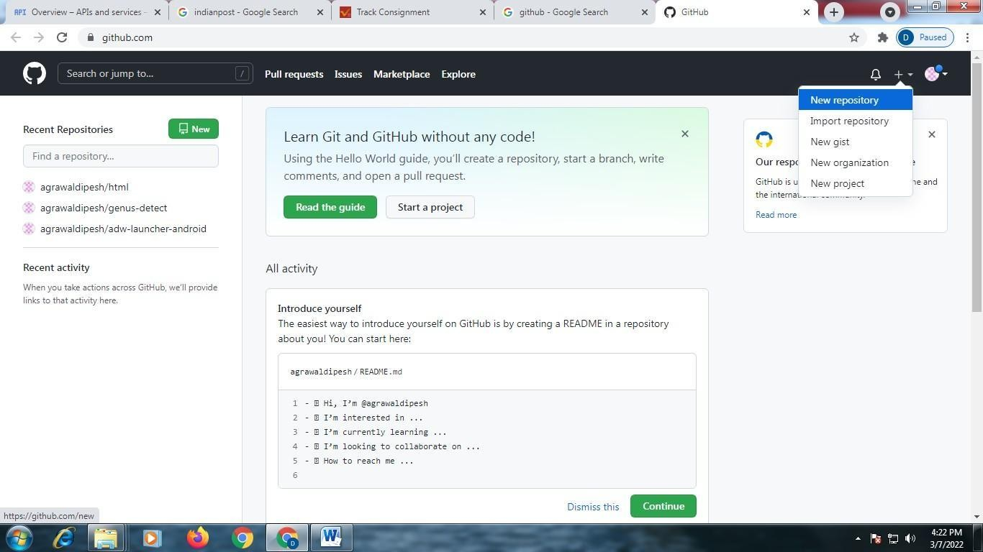

Give repository name as – ―LP2_Programǁ

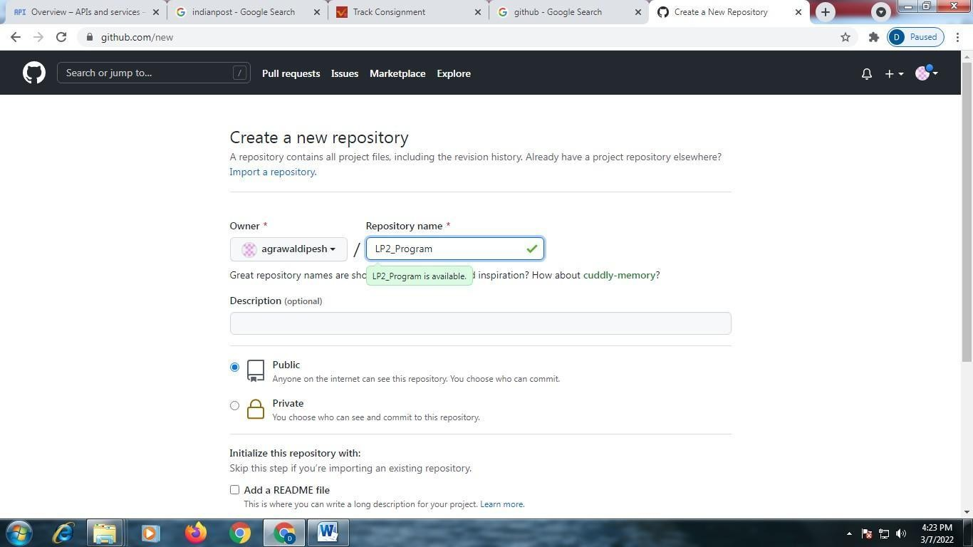

Scroll Down and Click on ―Create Repositoryǁ

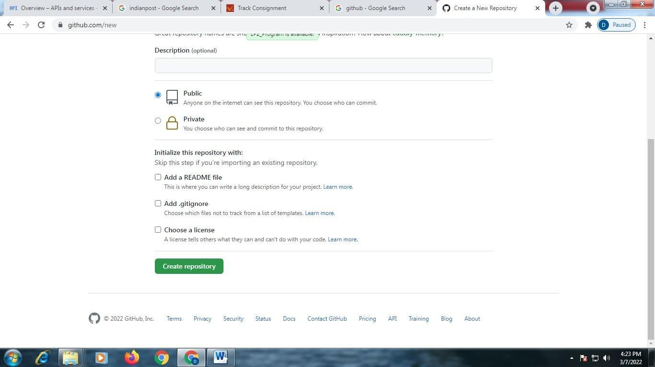

Click on ―Creating a new Fileǁ □

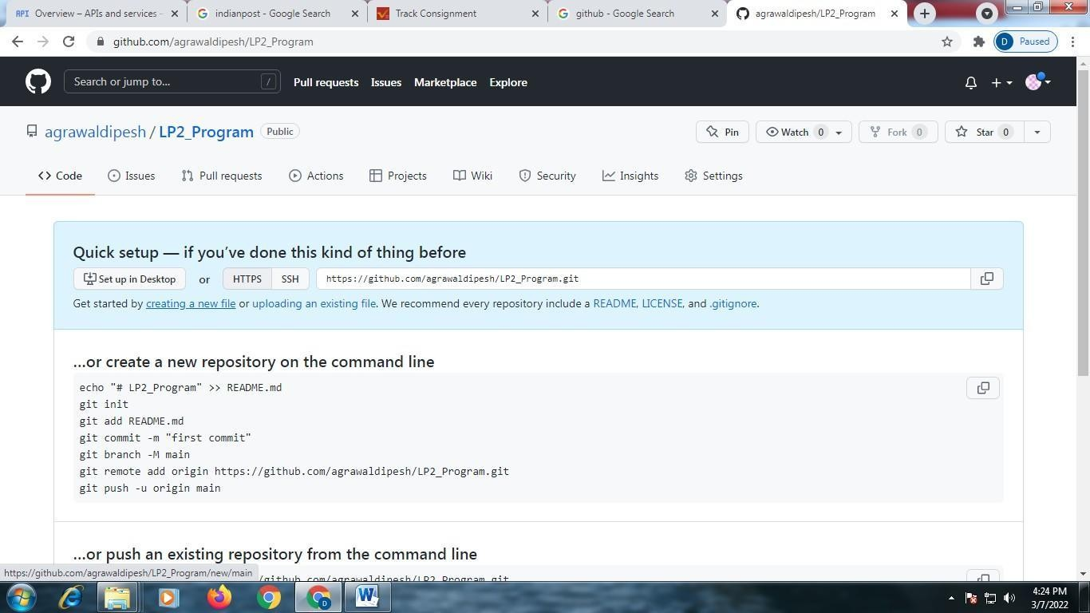

Give any name to the python file, like □ Program.py

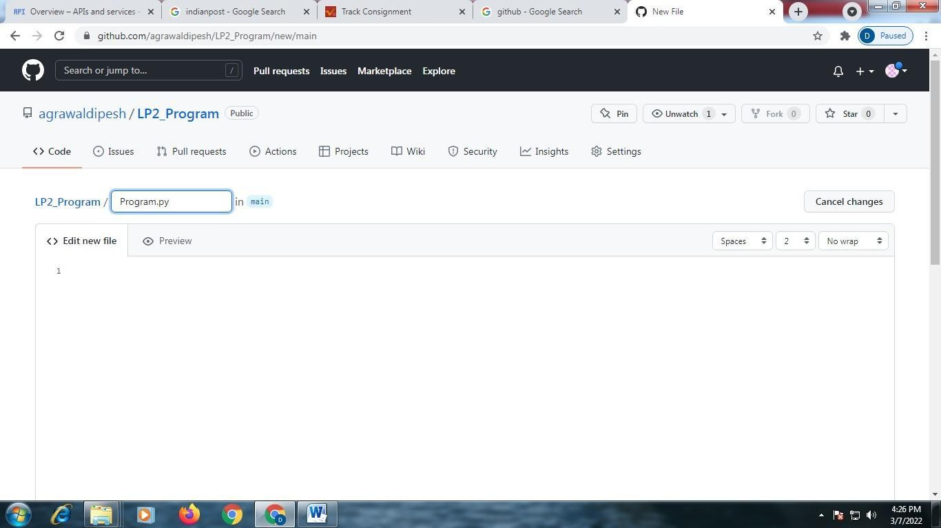

Type your code □ Print(―helloǁ)

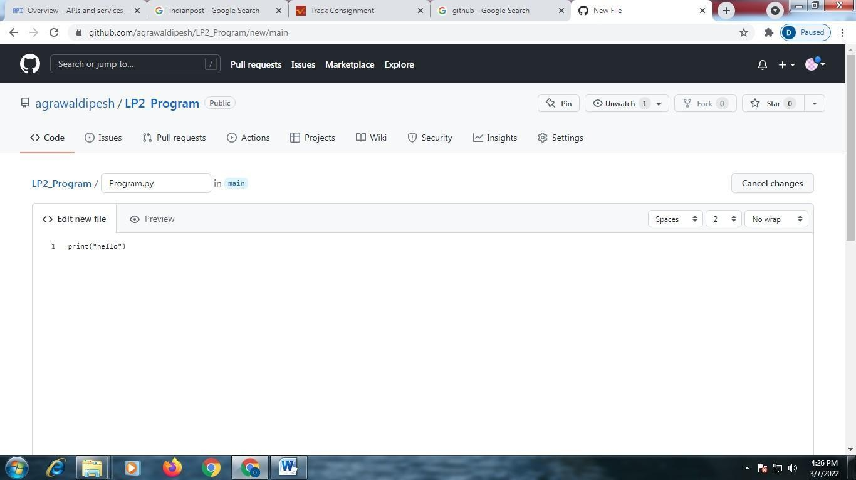

Scroll Down and Click on ―Commit new fileǁ

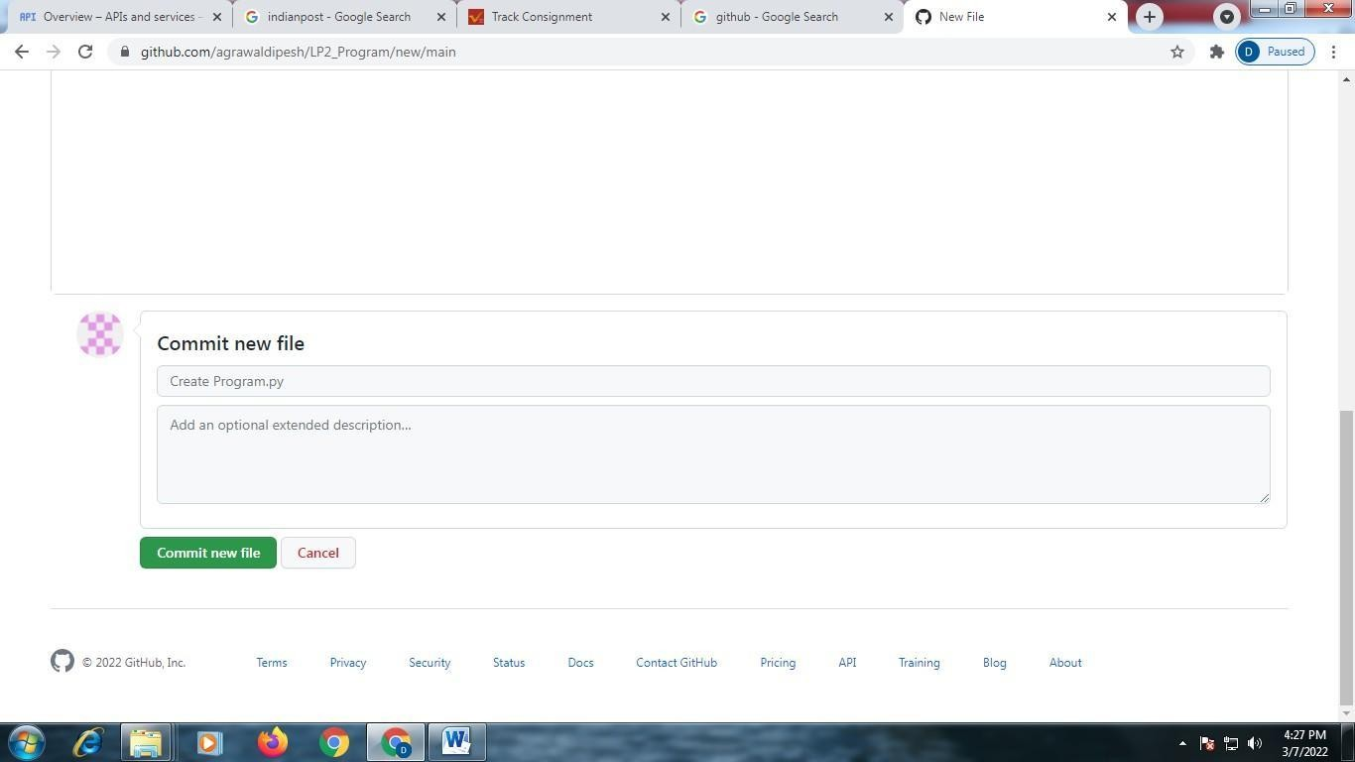

Click on ―Codeǁ and Copy URL □

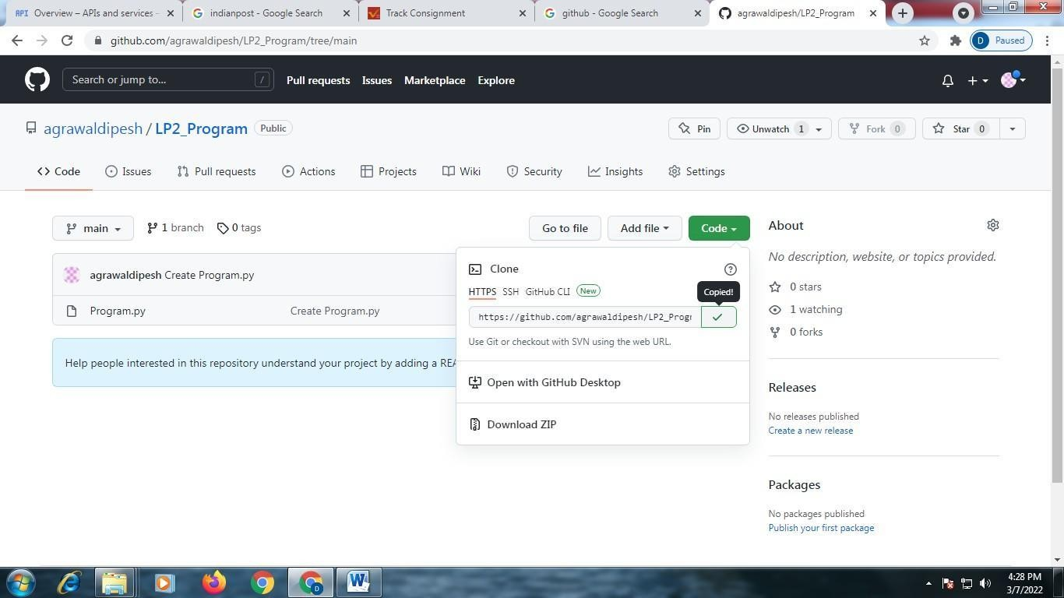

Go to cloud platform □ type ―git cloneǁ {Paste URL Here}

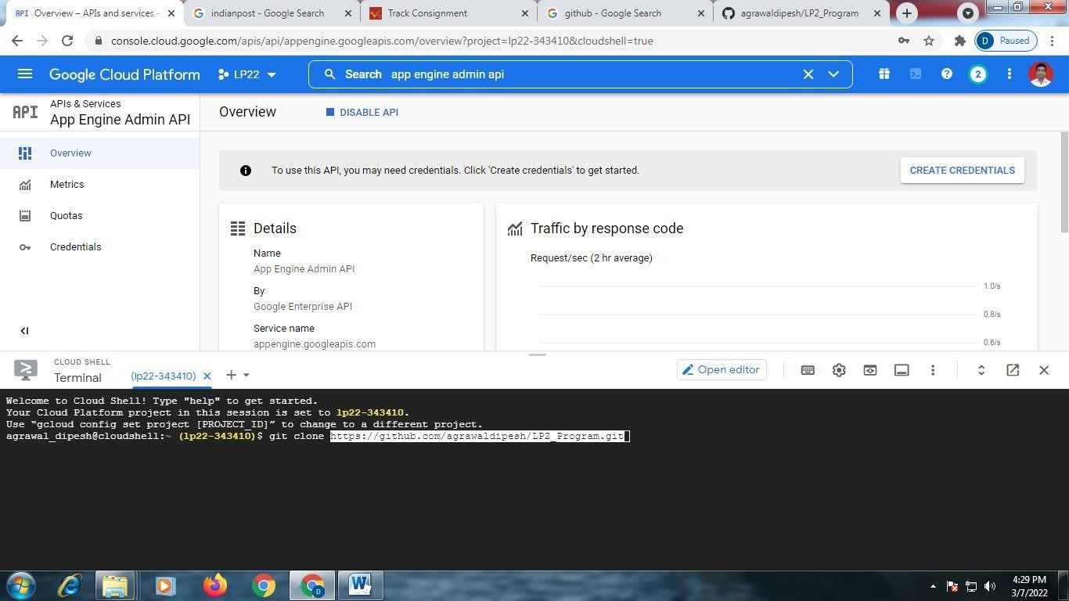

Type ―lsǁ

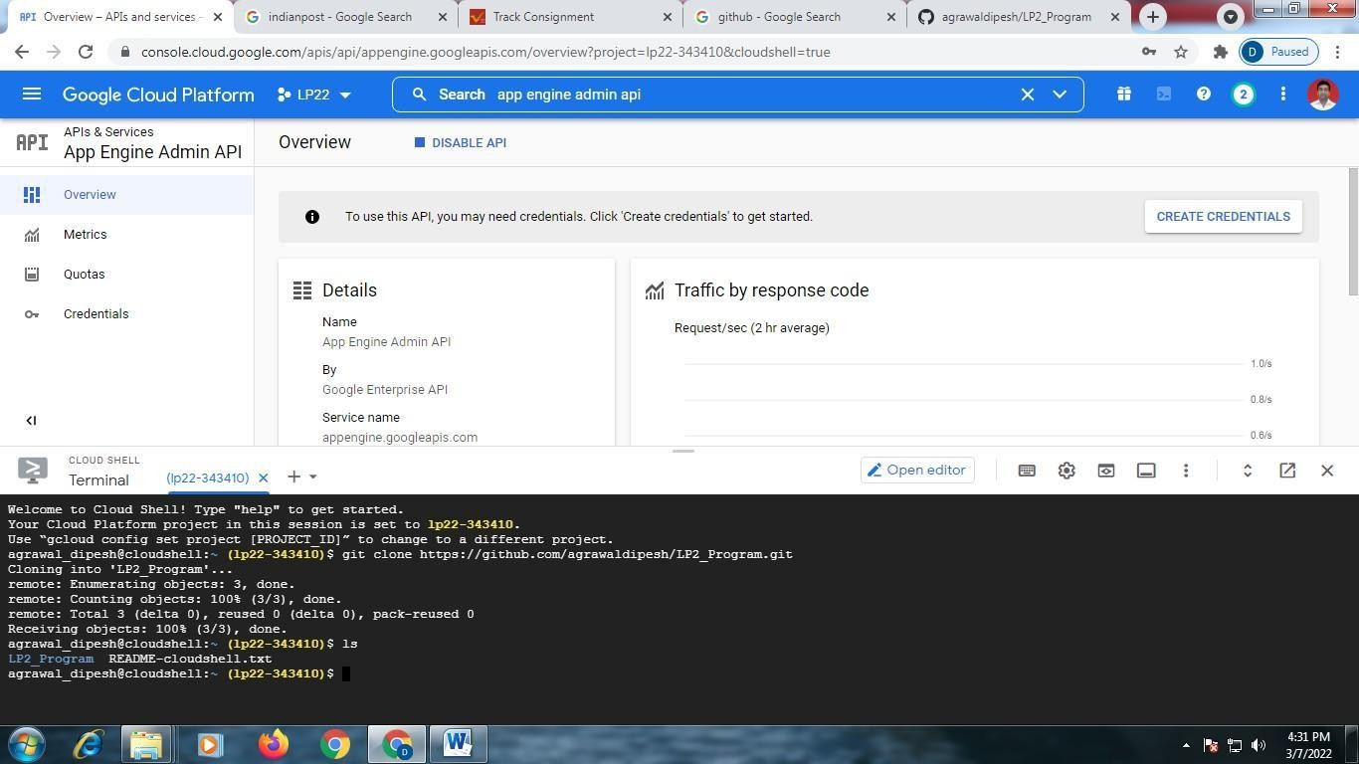

Enter into repository, using command □ cd repository name (here it is – LP2_Program) □ ls

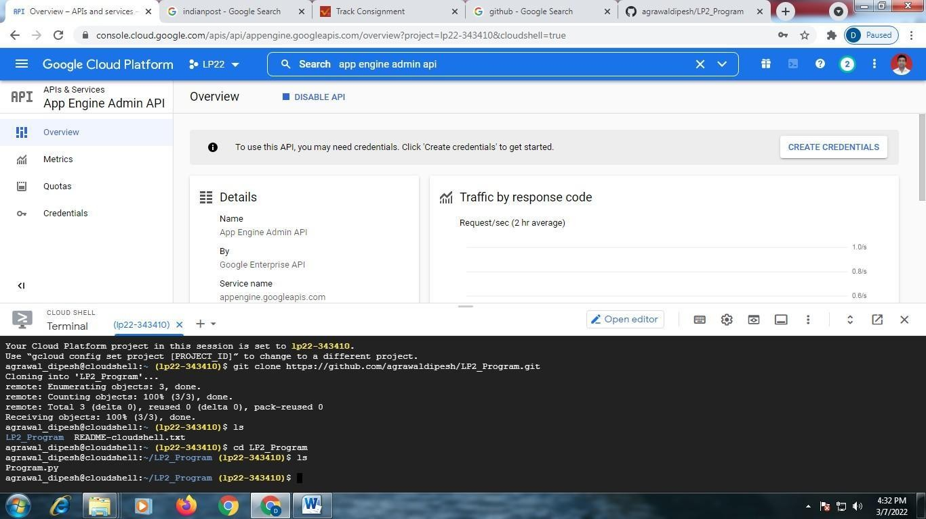

Type □ python filename (here it is -Program.py) Output is displayed

## Frequently Asked Questions:

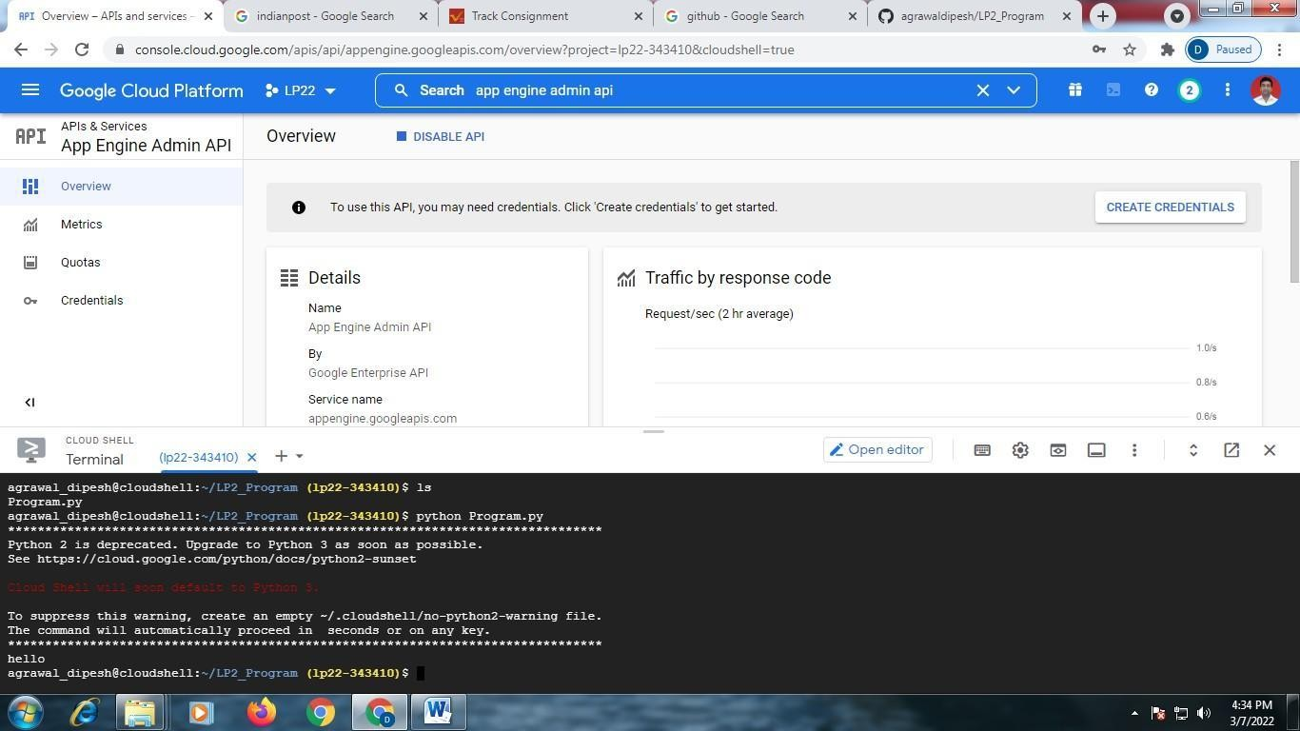

1. What is Google App Engine ?
2. What is difference between SQL and GQL ?
3. What are the advantages of Google App Engine over Amazon EC2 ?
4. What is Kubernetes ?
5. What is AppScale ?

## 7.Conclusion:

Successfully Installation and configure Google App Engine

**Course Name:**Laboratory Practice II(310258):Cloud Computing

**Class:**Third Year (TE)

**Assignment No:** 3

## Title of Assignment:

Creating an Application in SalesForce.com using Apex programming Language.

## Objective:

* 1. To learn the salesforce environment.
  2. Create a small application using APEX programming language.
  3. **Outcome:** Use tools and techniques in the area of Cloud Computing

## Software and Hardware Requirement:

**Software Requirement:** login required for SalesForce.com

**Hardware Requirement:** Internet Connection, PC with Min. 2GB RAM, Core i5 Processor

Steps –

Open [www.salesforce.com](http://www.salesforce.com/) website in browser.

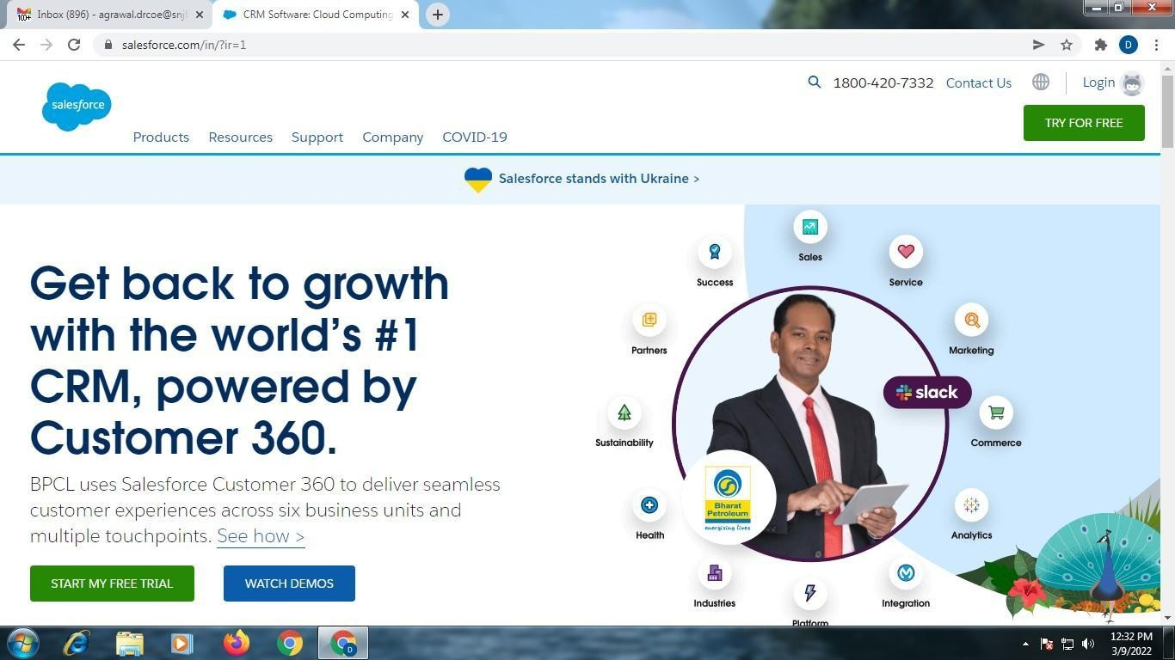

Create Your Account ?

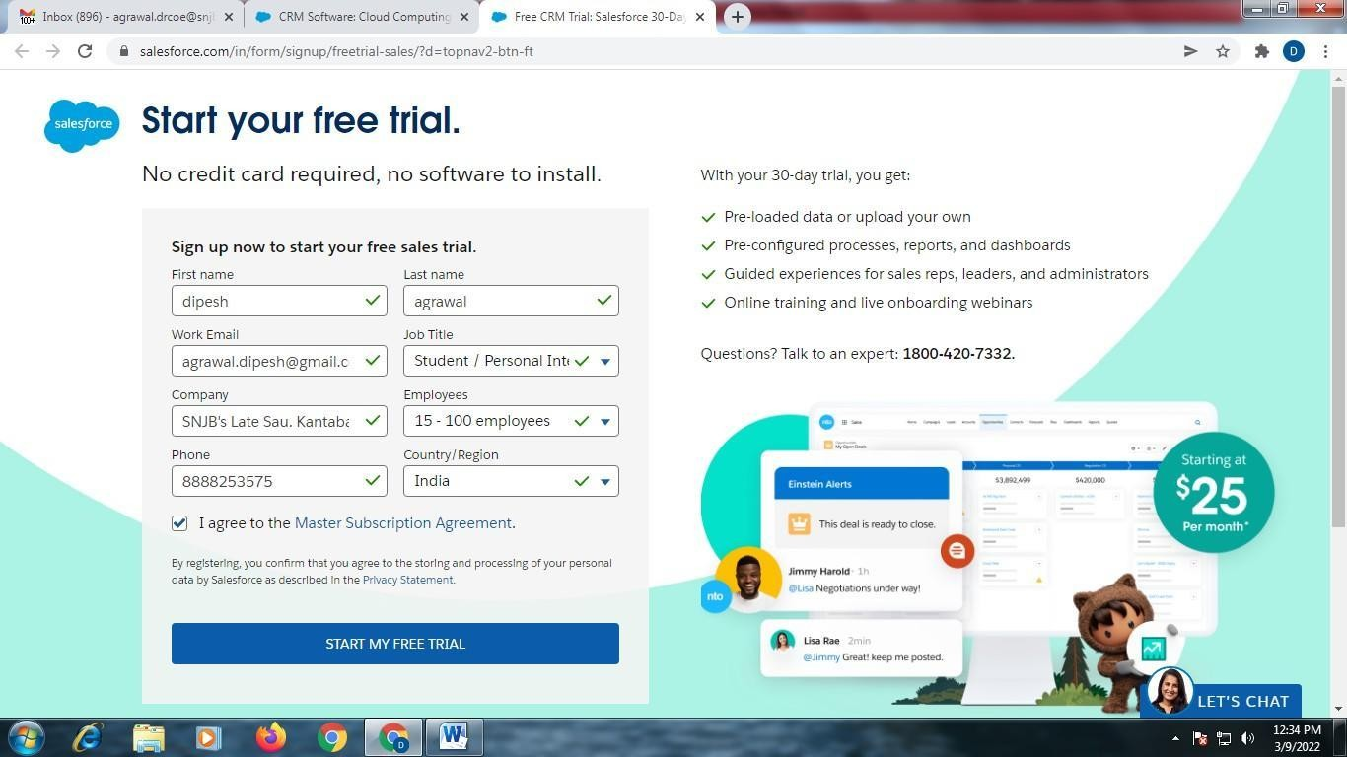

Enter Login-id and Password ?

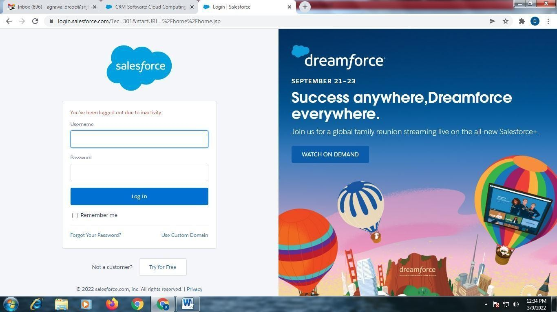

Following Screen will appear ?

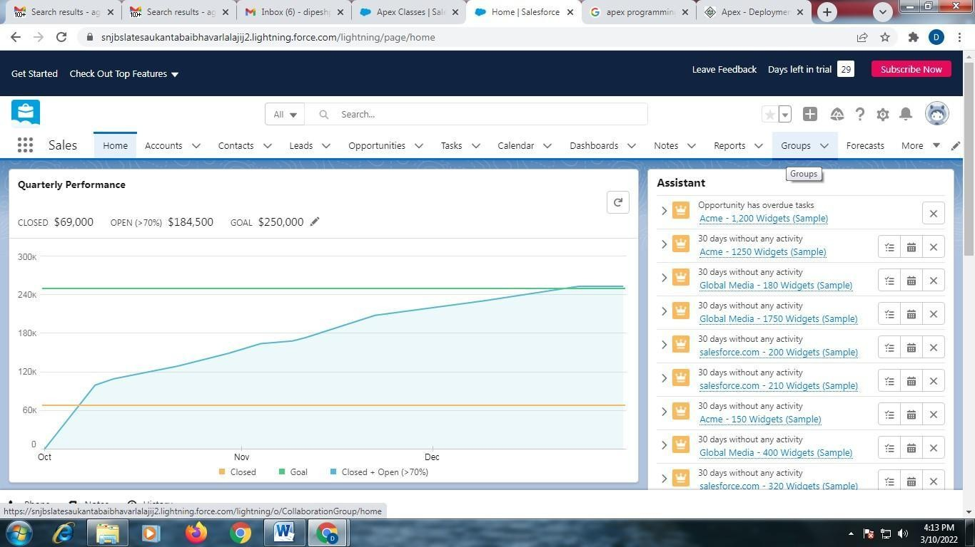

Click on “Setup”

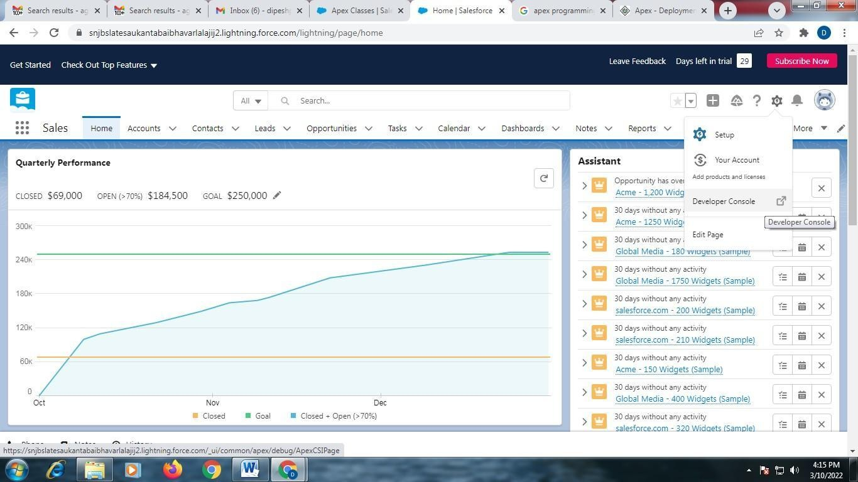

Click on “Developer Console”

Create Account on Developer Console, using following steps ? Developer.salesforce.com/signup



Enter your First Name, Last Name and Email Select your Job Role as – Developer

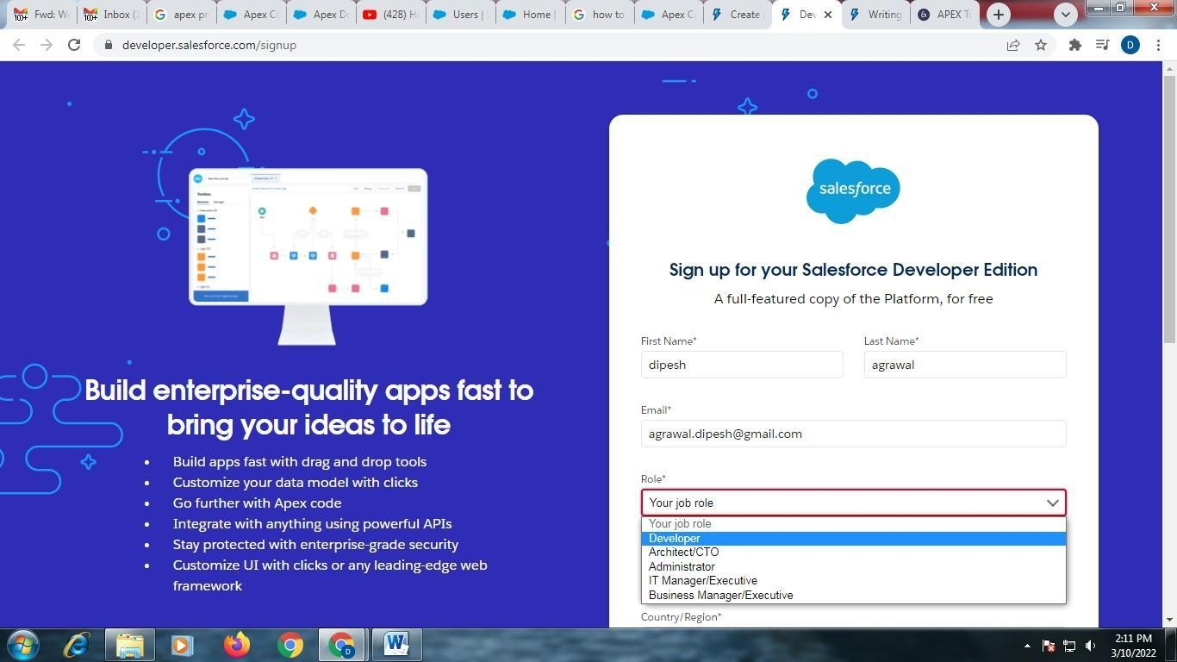

Enter Your Company Name Select Country / Region

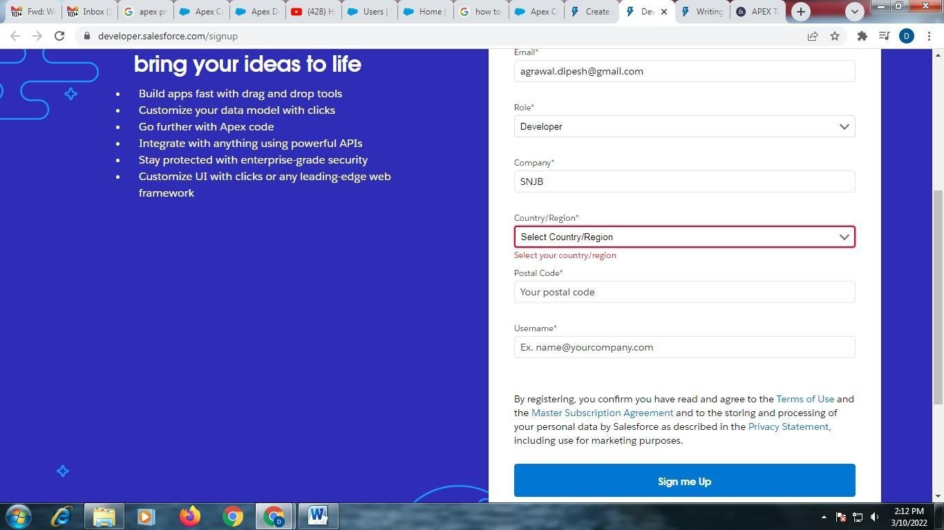

Enter Your Postal Code

Enter user name ? different than your Email-id

For ex. I have used email id for my salesforce account as ? dfgdfg.ghjghj[@gmail.com](mailto:agrawal.dipesh@gmail.com),

Then, for Developer account, I will use different email-id as

? jghjghjgh.fujifuiuy[@gmail.com](mailto:agrawal.dipesh123@gmail.com)

You will get an email of verification link in your email account, as below ? click on “Verify your account”

Following Screen Will Appear ?

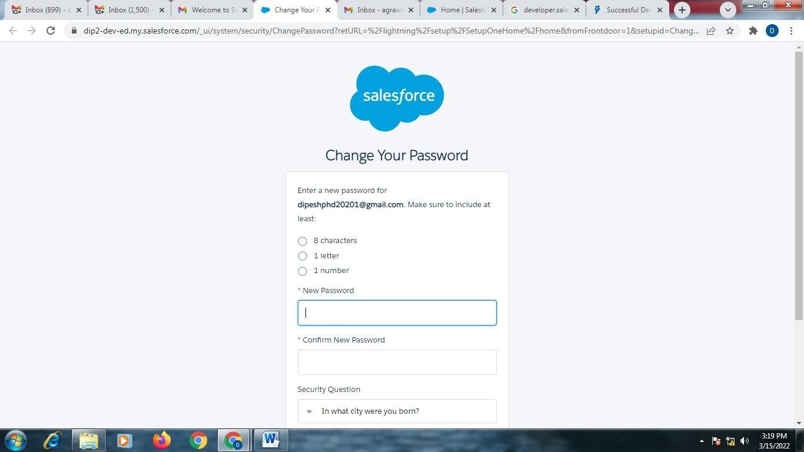

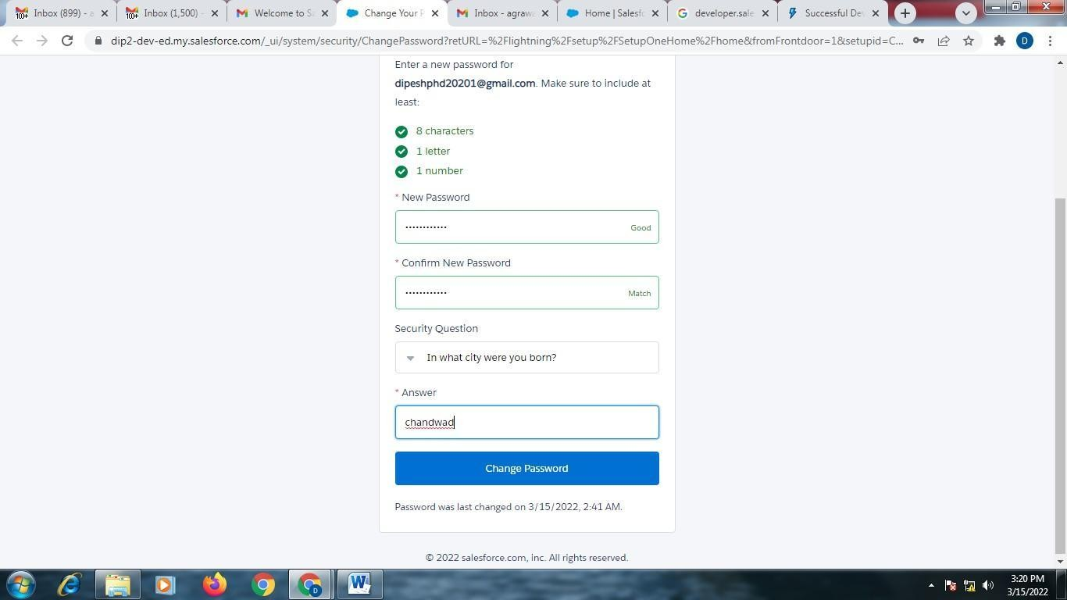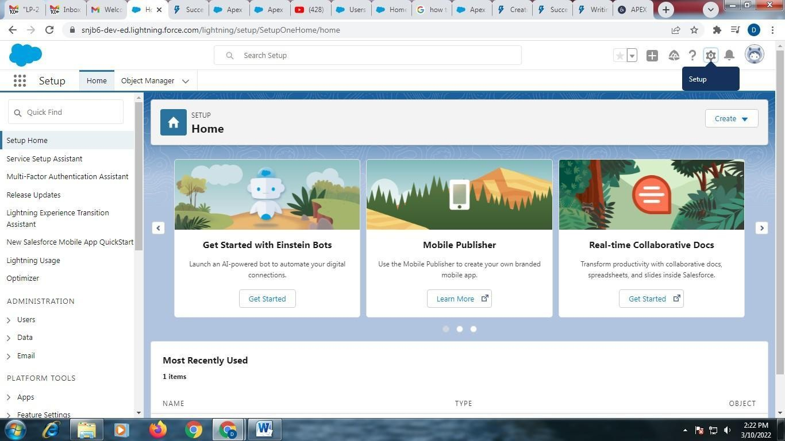

Enter Password, Security Question and Answer of itClick on ? “Change Password” Following Screen Will Appear ?

Click on ? Setup

Select ? Developer Console

Developer Console will be opened as below ?

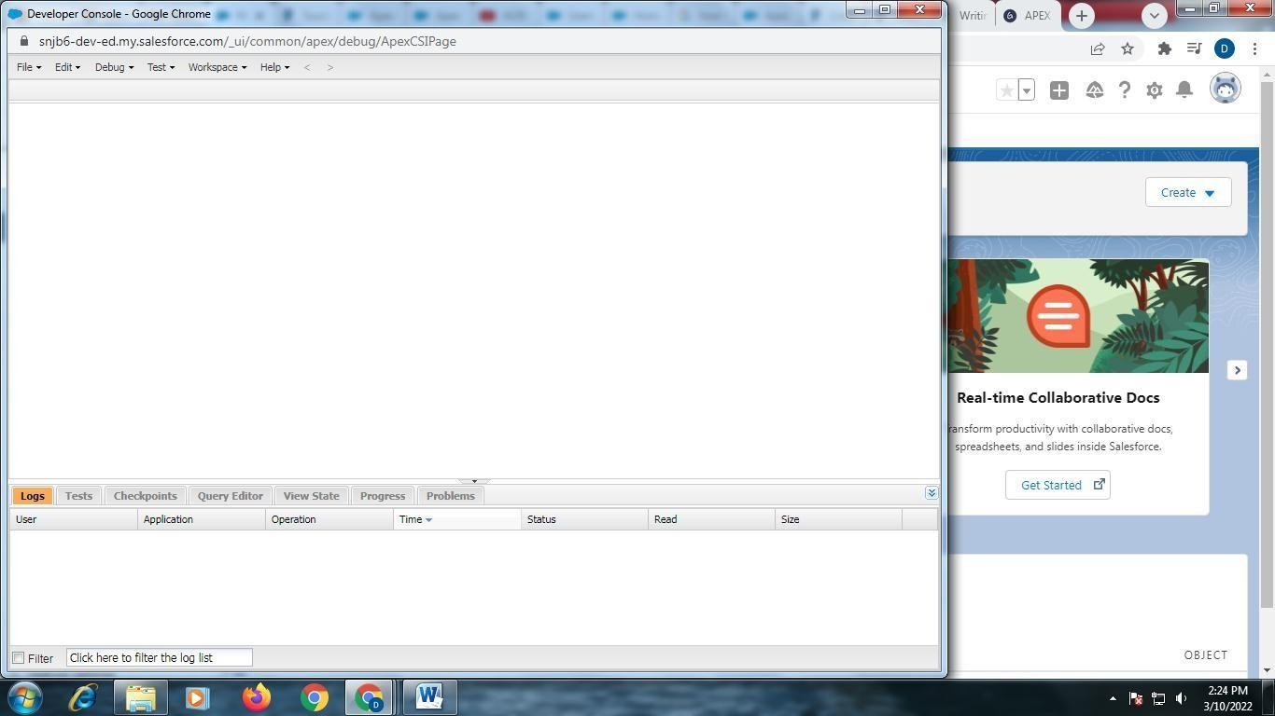

File ? New ? Apex Class

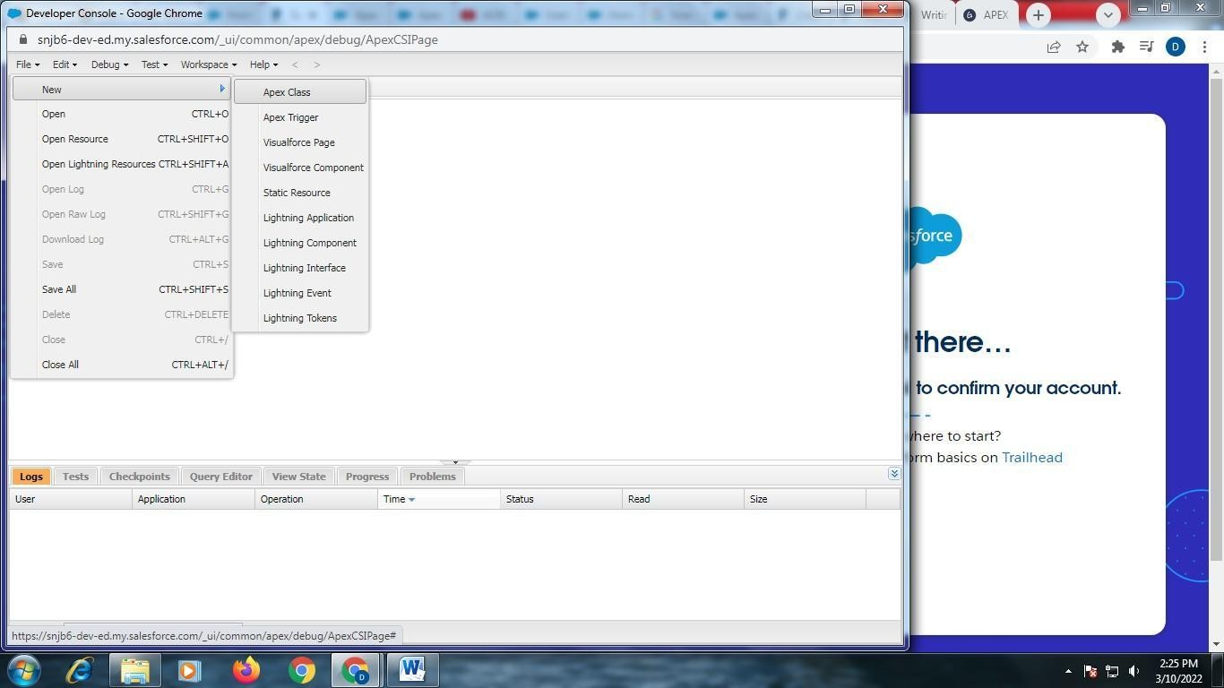

Enter name for your new apex class ? as “one”

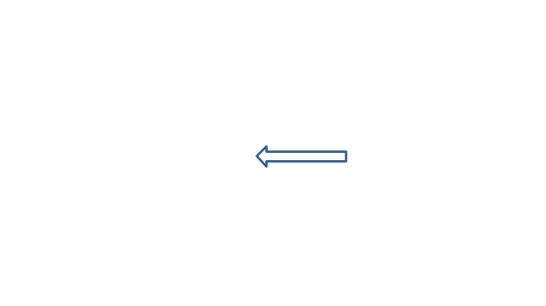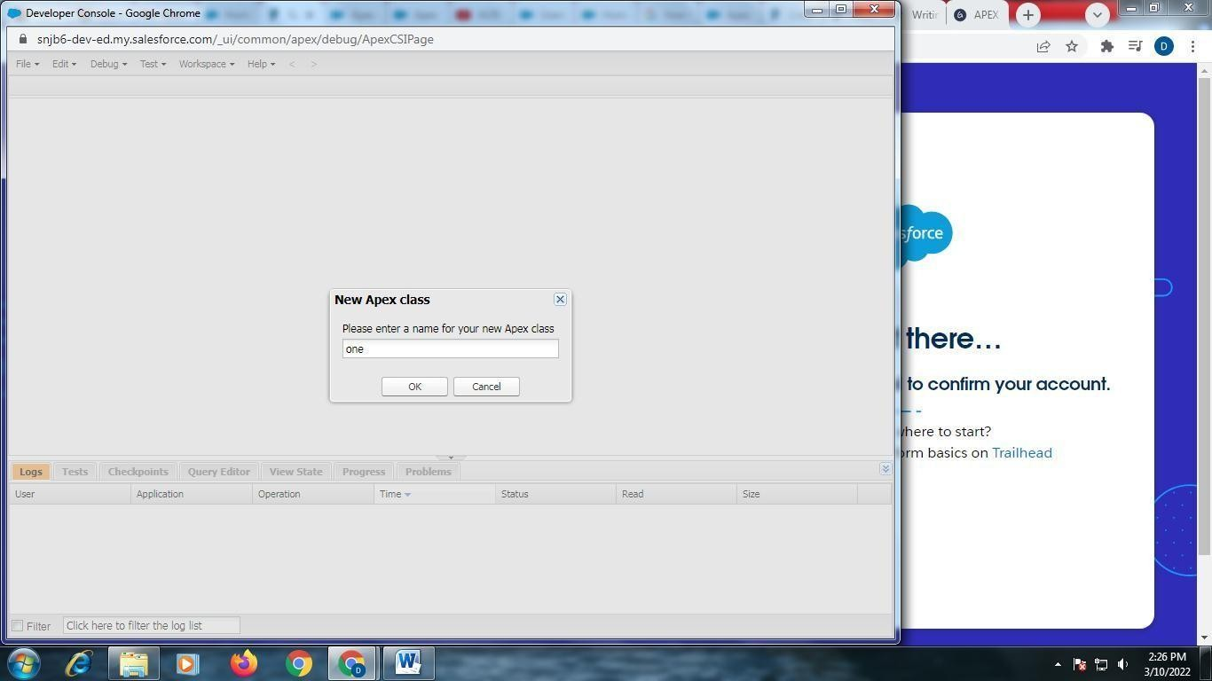

Write Following Code ?

public class one

{

public static void onemethod()

{

System.debug(„hello‟);

}

}

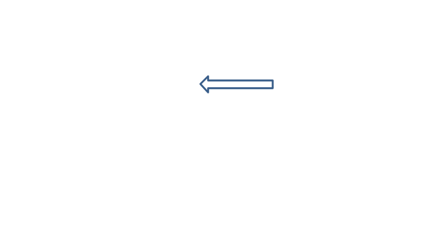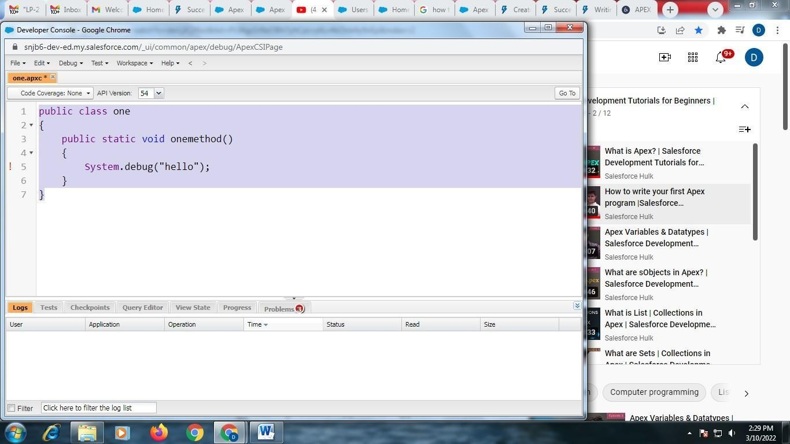

Save the code using File ? Save

Debug the code using following steps ?

Debug ? “Open Execute Anonymous Window”

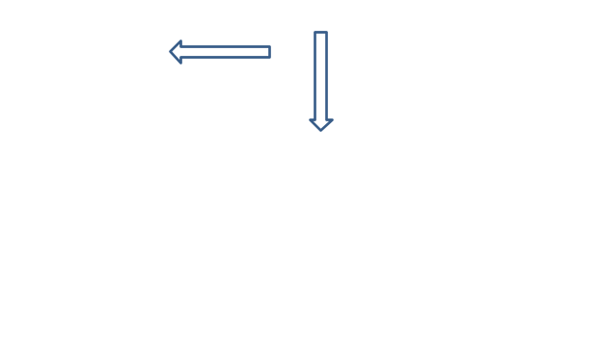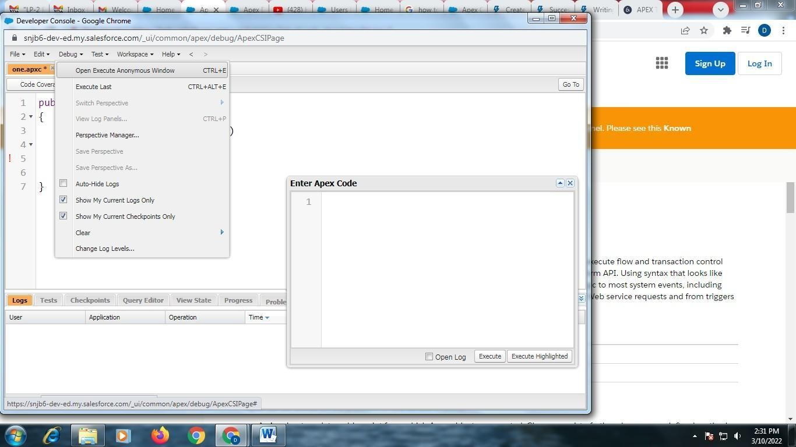

In “Enter Apex Code” window, Type “one.onemethod();”

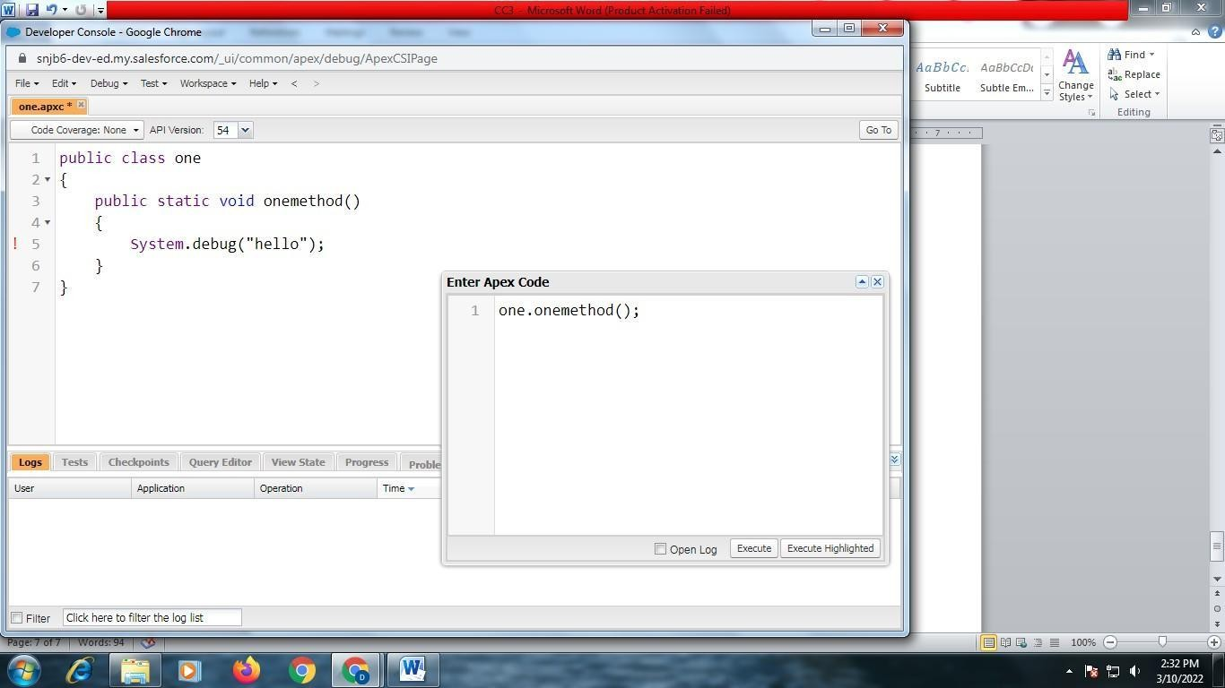

Click on “Open Log” Checkbox ?

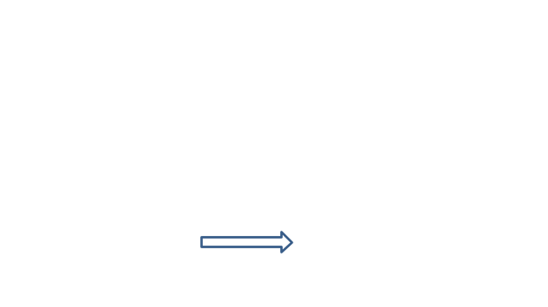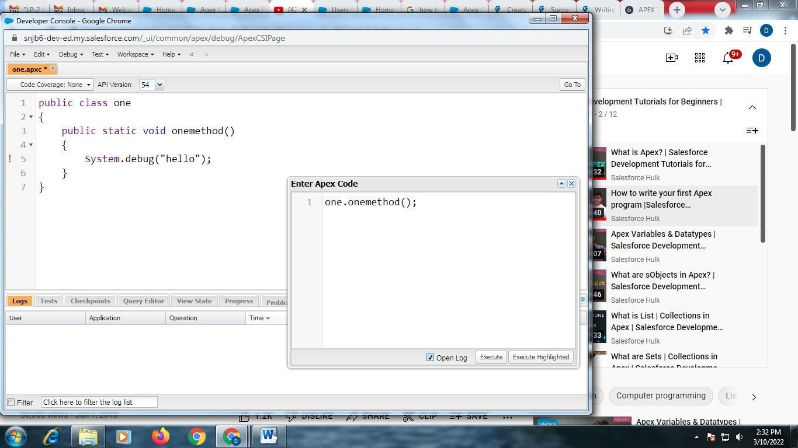

Click on “Execute” Button

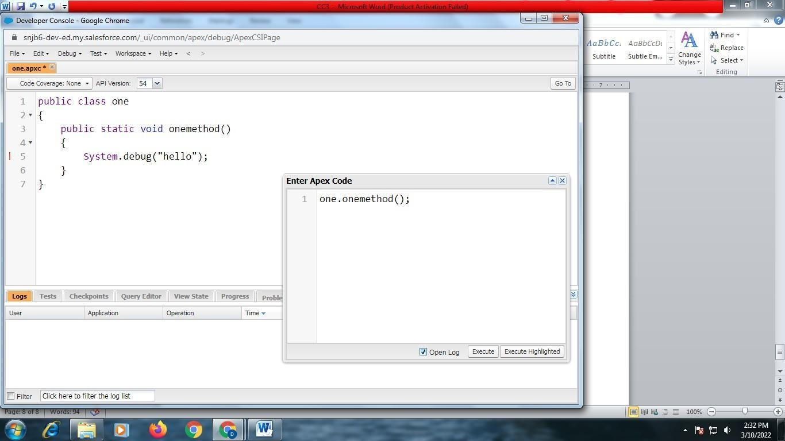

Debug Log will be opened in the following window

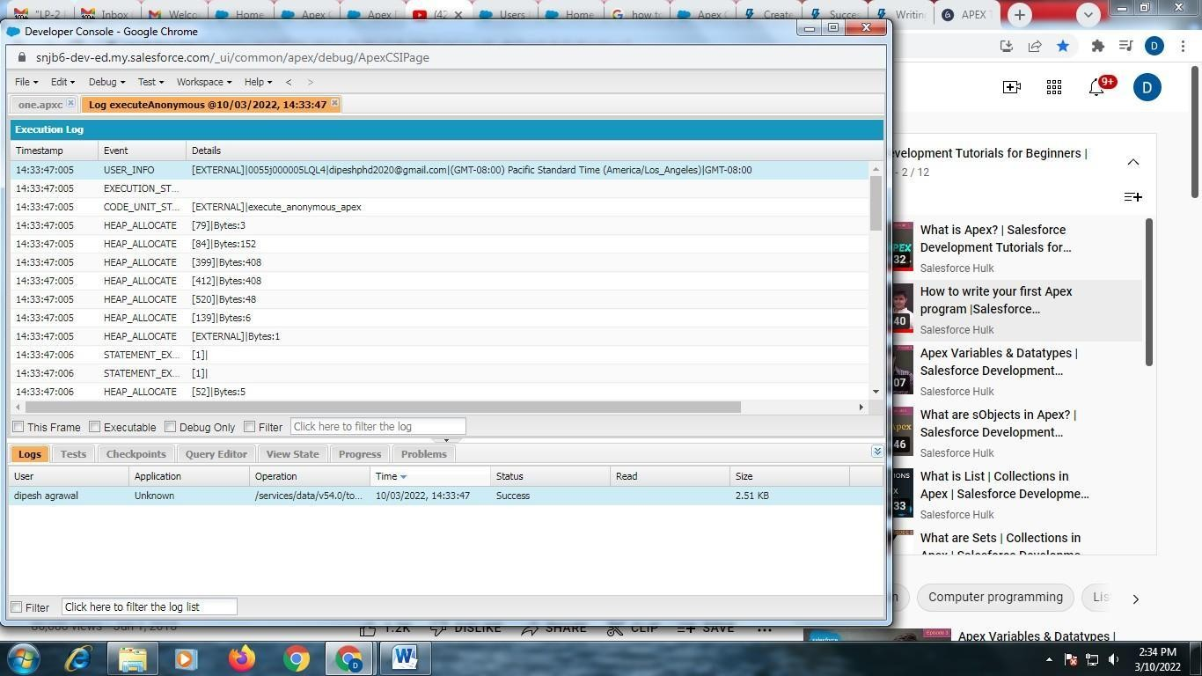

Click on “Debug Only” checkbox ?

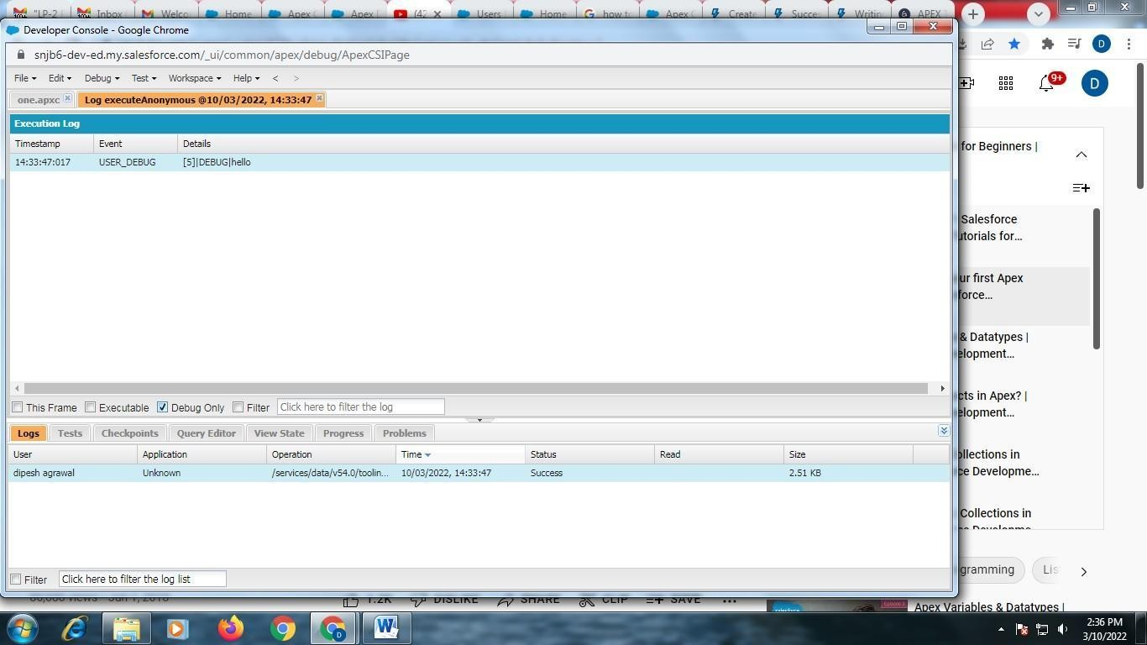

Observe the output in ? “Execution Log”

**Assignment Questions** □

1. What is Salesforce?
2. What does Salesforce do?
3. What is Salesforce used for?
4. What is Apex?
5. When Should Developer Choose Apex?

## Conclusion □

Created an Application in SalesForce.com using Apex programming Language.

**Course Name:**Laboratory Practice II(310258):Cloud Computing

**Class:**Third Year (TE)

**Assignment No:** 4

## Title of Assignment:

Design and develop custom Application (Mini Project) using Sales force Cloud.

## Objective:

* 1. To Learn & develop the application in Salesforce.com
  2. Create Application in Salesforce
  3. **Outcome:** Design and develop applications on cloud

## Software and Hardware Requirement:

**Software Requirement:** login required for SalesForce.com

**Hardware Requirement:** Internet Connection, PC with Min. 2GB RAM, Core i5 Processor

What Is Custom Application Development?

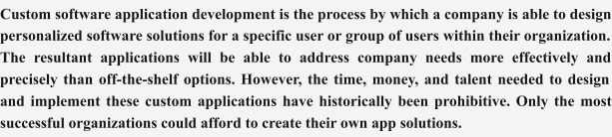

**Steps in Details:**

**Steps for creating & Starting Saleceforce.com applcaiton**

**Step-1:** Account Creation in Salesforce

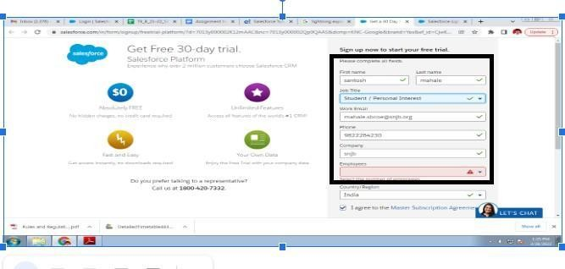

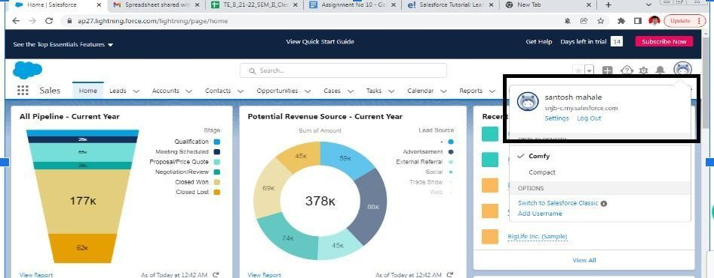**Step-2:** Logged into salesforce.com by registered user

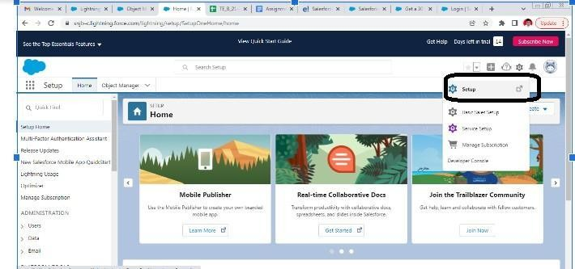**Step-3:** Click on a **Setup** from setting (Right side of the top corner)

**Step-4:** Search for **App Manager** and click on **New Lightning App**

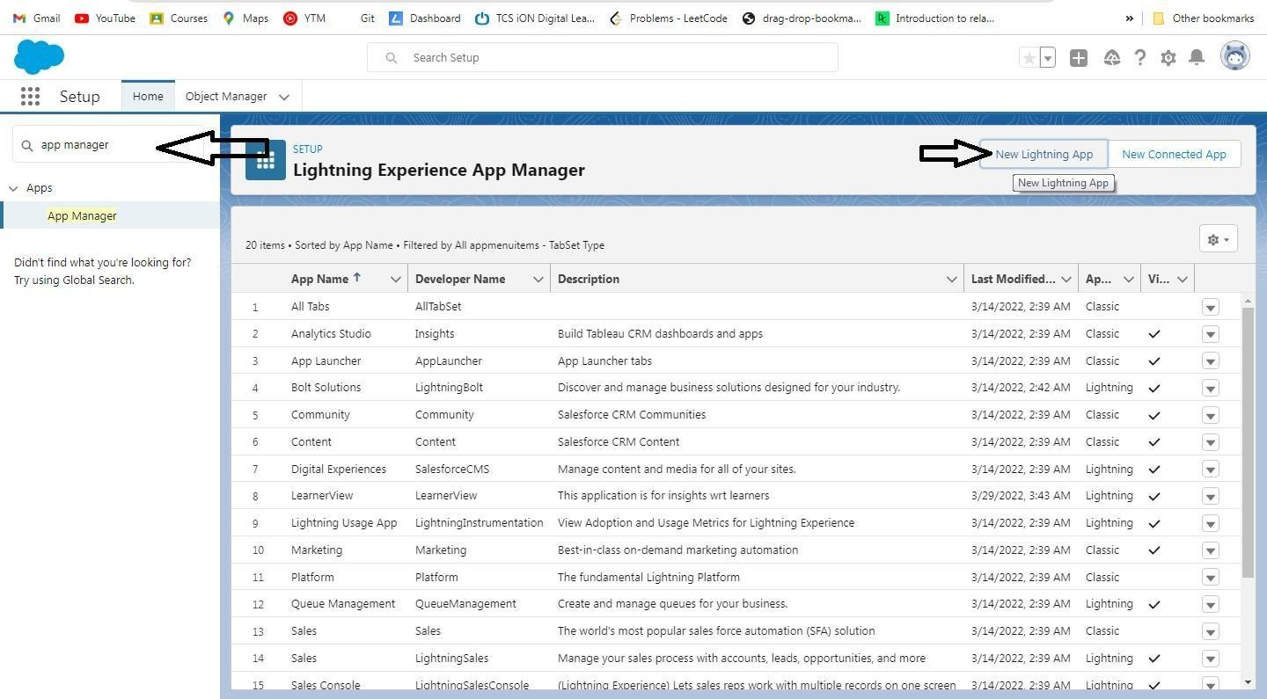

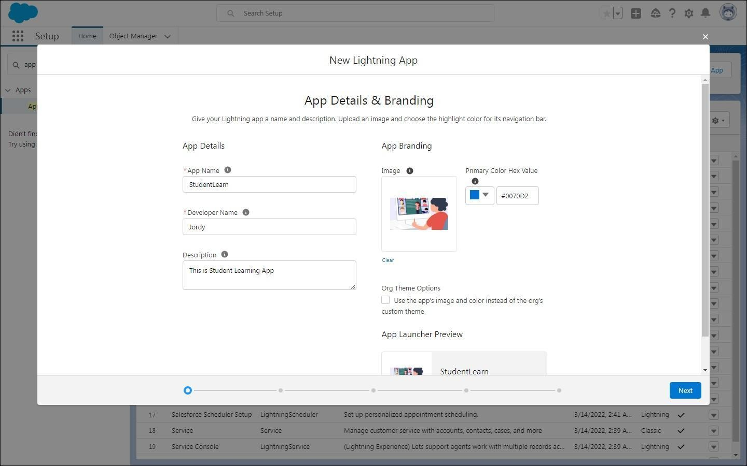**Step**-**5:** Give **App Name**, fill in other details and click on **Next** button

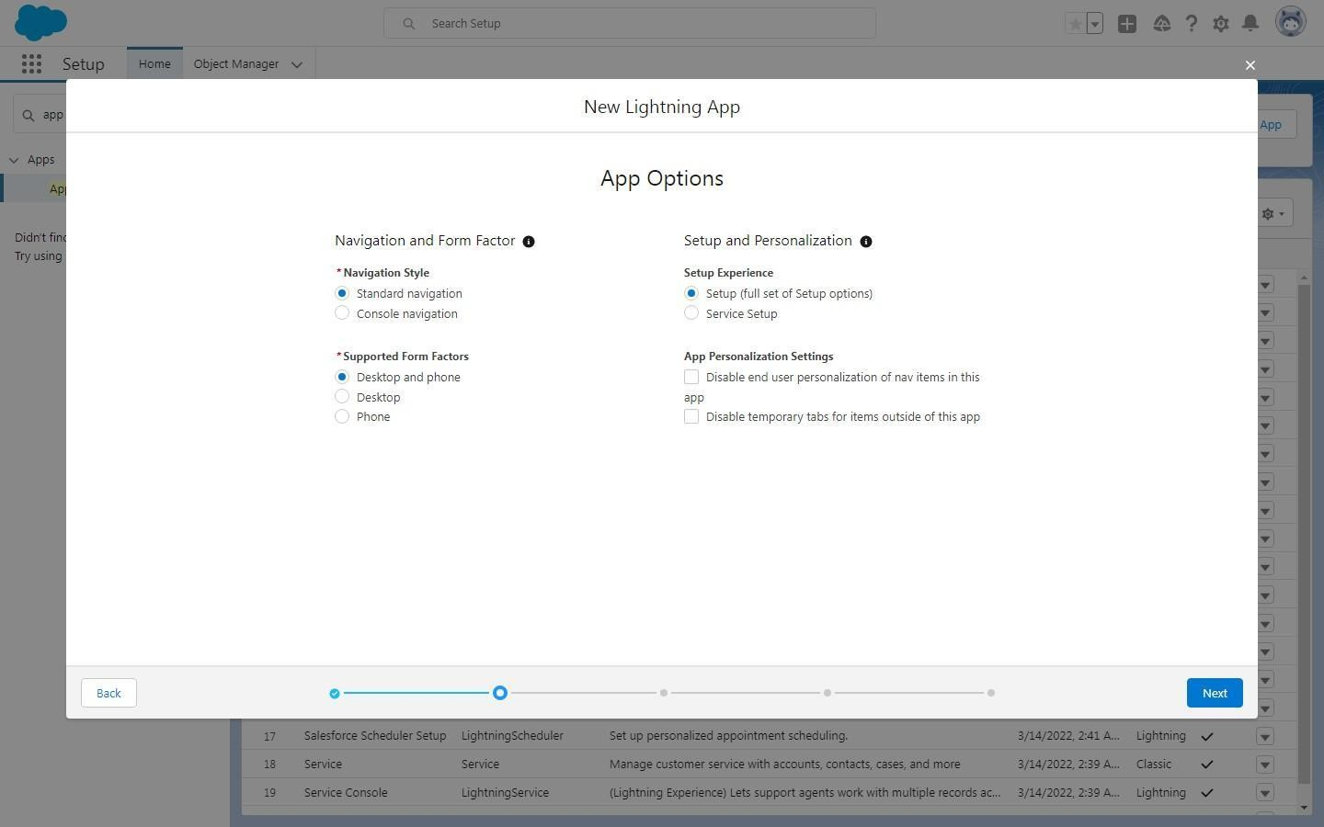**Step**-**6:** Click **Next again** in-app option

## Step-7: Add Utility Items

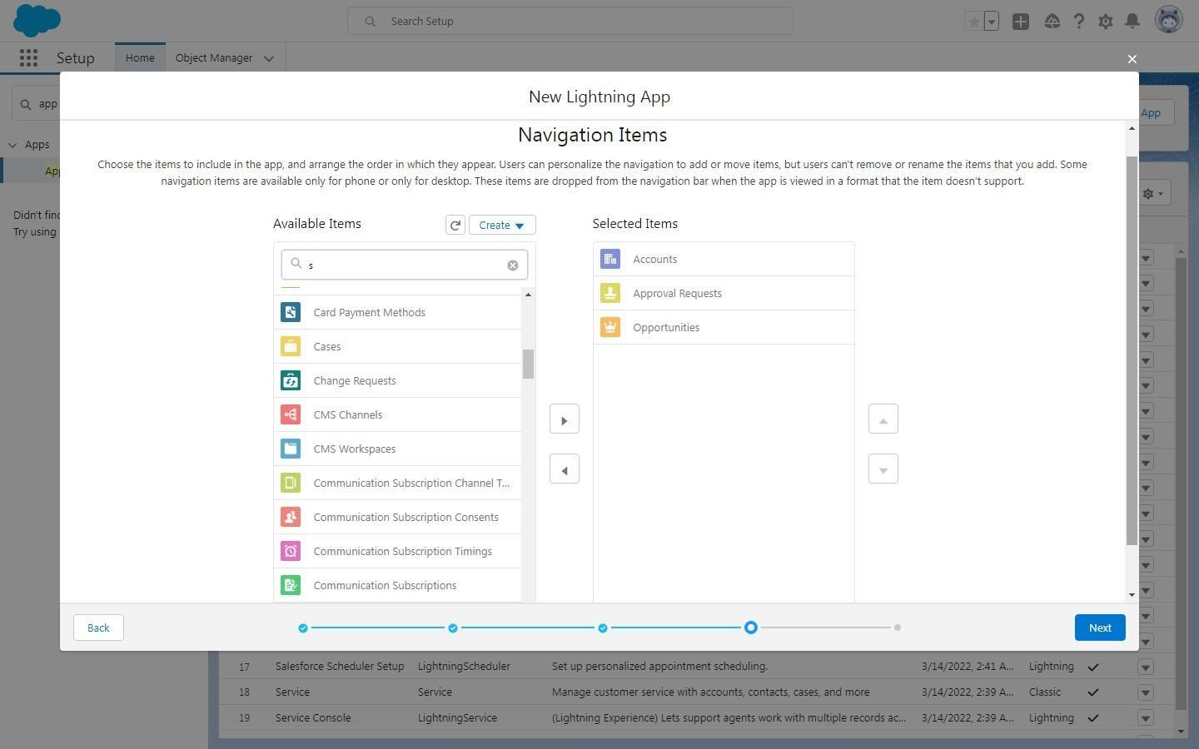**Step-8: Add Navigation Items**

**Step-9:** Choose the **user profiles** that **can access this app** and **Click** on **Save** &**Finish button**

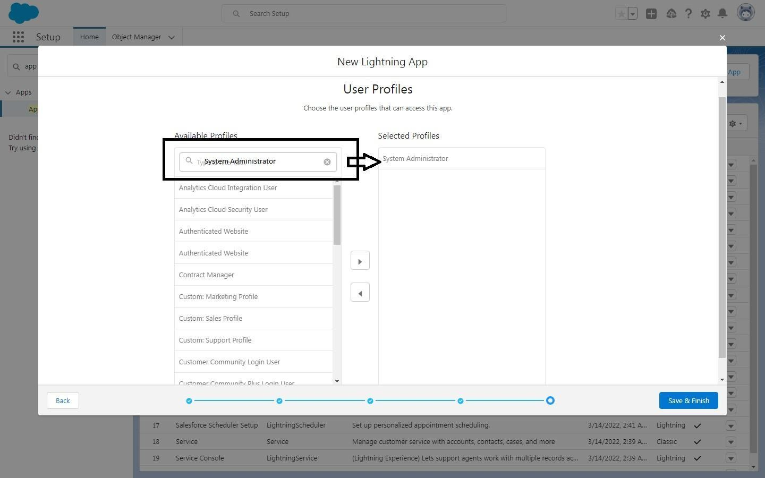

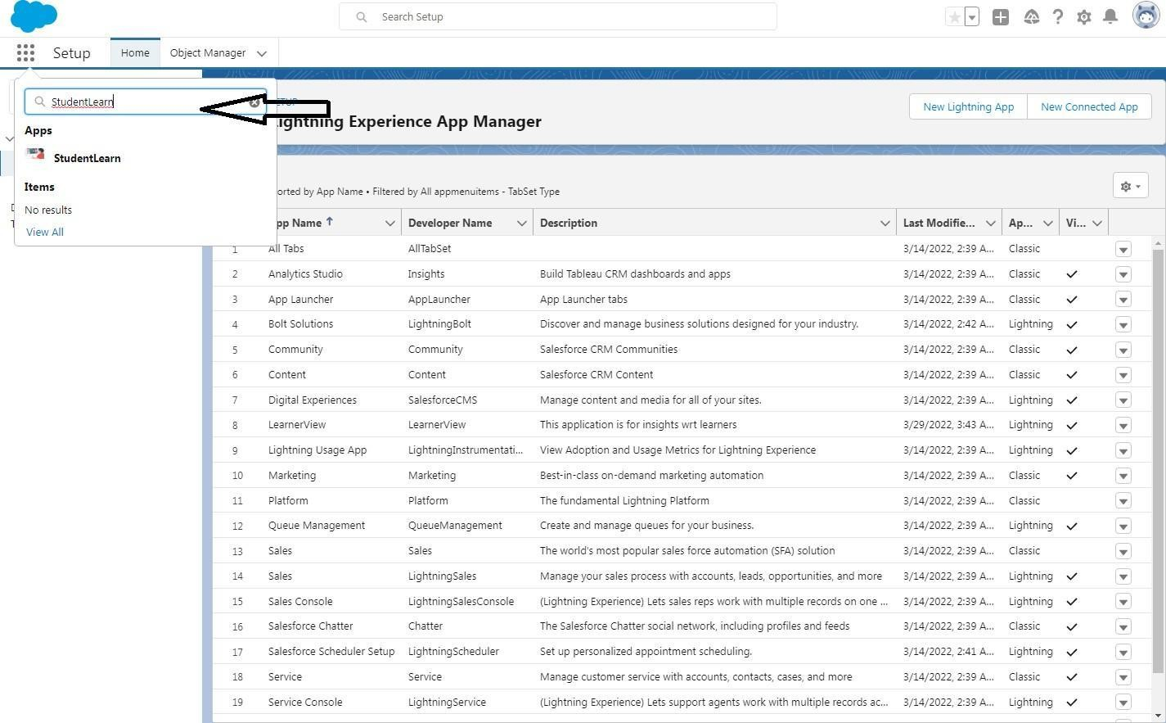**Step-10: Search** for the Application Name: **StudentLearn**

## Step-11: Finally, we get the Custom Fields / Labels as shown below,



**Step- 12:** Click on **New Button** for Adding Records & Finish

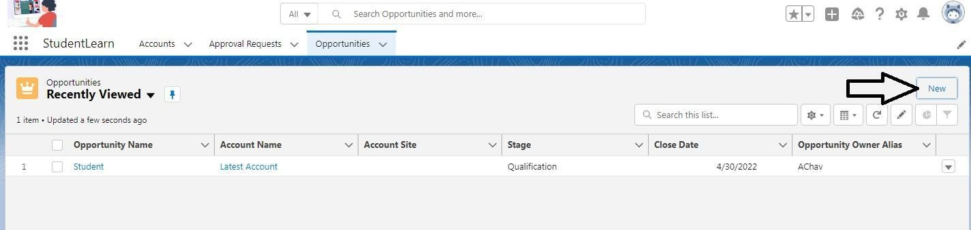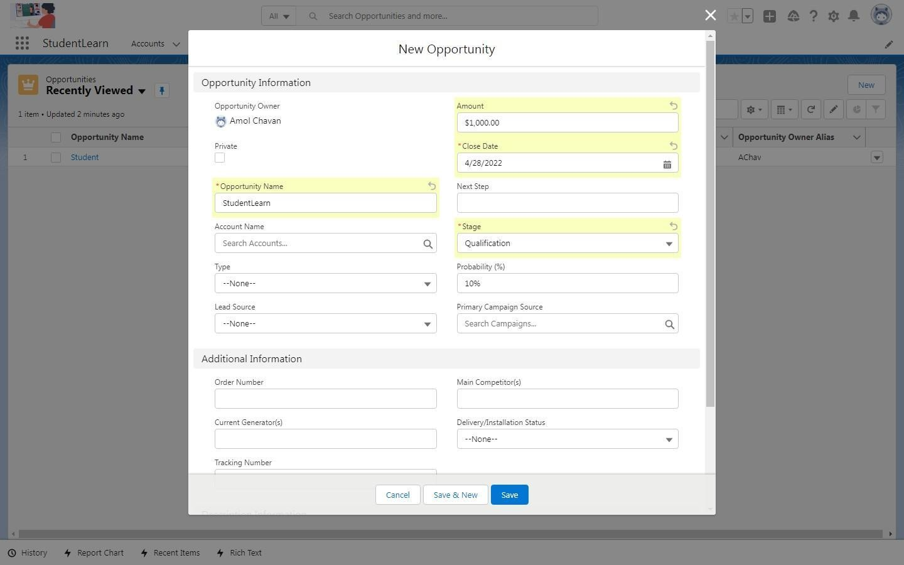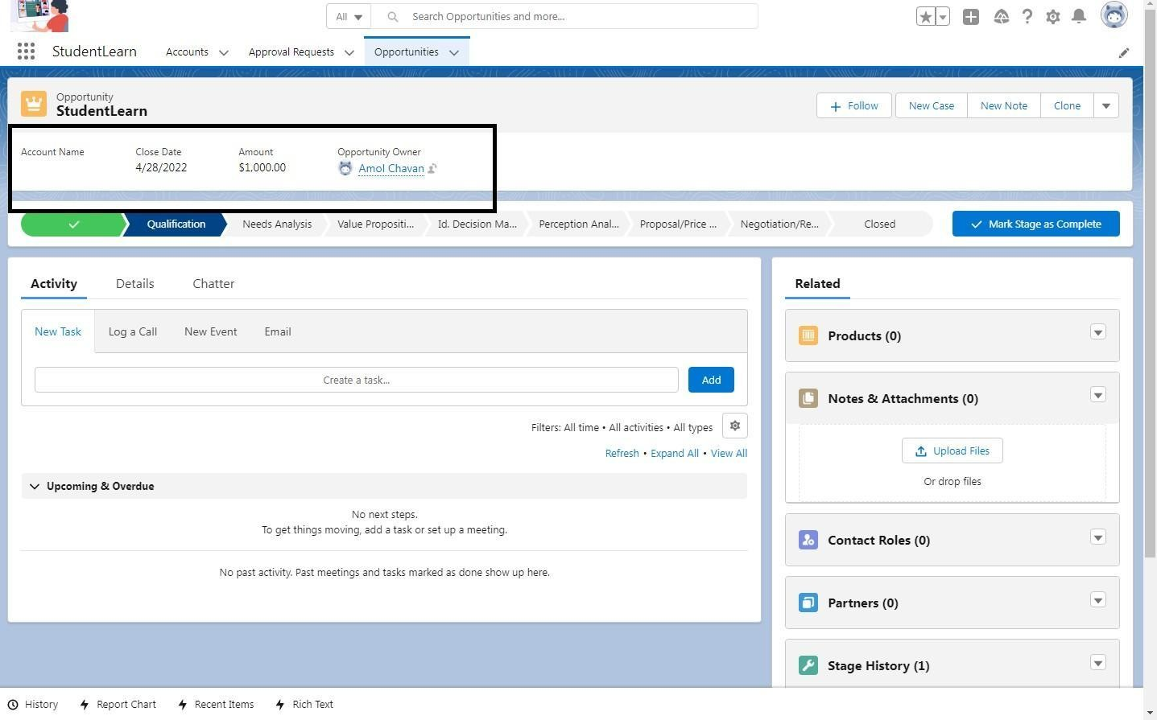

## Frequently Asked Questions:

1. What is Lightning Experience?
2. What Object Manager?
3. What are Custom Fields?
4. What is App Manager?
5. What is User Profile in Ligtnng App?

## Conclusion:

Hence, successfully created the custom Application SalesForce.com.